

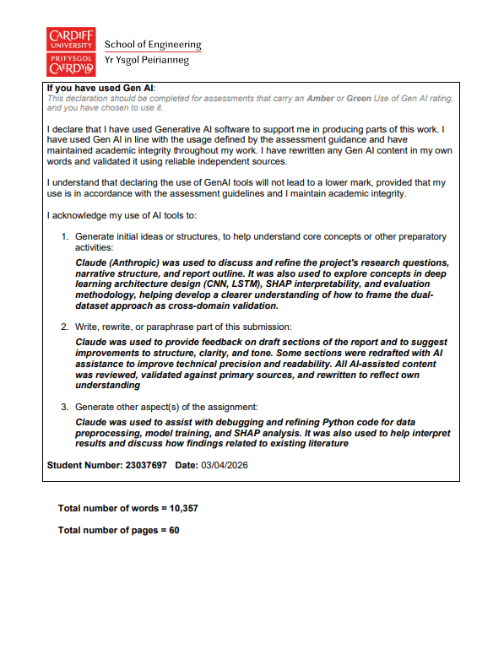

SCHOOL OF ENGINEERING
CARDIFF UNIVERSITY

Department of Mechanical and Medical Engineering

EN3100 PROJECT
FINAL REPORT

Using Machine Learning Algorithms for Predicting Remaining
Useful Life (RUL) of an Induction Motor

Student: Maximillian A. Hall Barr
Student Number: 23037697
Degree Programme: Mechanical Engineering (BEng)
Supervisor: Dr. Michael Packianather
Date: 27th March 2026

Abstract
Bearing failures account for over half of all induction motor breakdowns, making accurate prediction of bearing Remaining Useful Life a key challenge for industrial predictive maintenance. This project applied four models of increasing complexity: Linear Regression, XGBoost, 1D Convolutional Neural Network, and a CNN-LSTM hybrid, to bearing RUL prediction using the MFPT bearing fault dataset as the primary dataset and the NASA N-CMAPSS turbofan engine dataset for cross-validation.
On MFPT bearing data, the 1D-CNN achieved the best performance with RMSE of 11.60, a 62% improvement over XGBoost and the largest single improvement of any model transition tested. On N-CMAPSS turbofan data, the CNN achieved RMSE of 5.85, more than halving the published physics-based benchmark of 12-15 cycles. The CNN-LSTM hybrid underperformed the CNN on bearing data (RMSE 13.90 vs 11.60) and performed comparably on turbofan data (5.81 vs 5.85), demonstrating that additional recurrent complexity does not improve bearing RUL prediction.
SHAP interpretability analysis identified kurtosis as the dominant bearing degradation feature and compressor outlet temperature (T24) as dominant for turbofan data, both corresponding to established degradation physics. Deep learning consistently outperformed traditional machine learning across both datasets, with the CNN’s advantage being larger on single-channel bearing vibration (62%) than on multi-sensor turbofan data (37%). The methodology is validated as transferable across equipment types and sensor modalities, with the simpler 1D-CNN recommended for induction motor bearing applications.
Keywords: Remaining Useful Life, Predictive Maintenance, Convolutional Neural Network, LSTM, Bearing, Induction Motor, SHAP

Contents
Chapter 1: Introduction 9
1.1 Background and Context 9
1.2 Problem Statement 9
1.3 Aim, Research Questions and Objectives 10
1.4 Scope and Limitations 11
1.5 Report Structure 11
Chapter 2: Literature Review 12
2.1 Predictive Maintenance Fundamentals 12
2.1.1 Maintenance Strategy Evolution 12
2.1.2 Conventional Bearing RUL Methods and Their Limitations 12
2.2 Machine Learning for Bearing RUL prediction 13
2.2.1 Traditional Machine Learning 13
2.2.2 Ensemble Methods 13
2.2.3 Feature Engineering for Bearing Data 13
2.3 Deep Learning for Time-Series Prognostics 15
2.3.1 Convolutional Neural Networks 15
2.3.2 LSTM Networks 16
2.3.3 Hybrid CNN-LSTM 16
2.3.4 Complexity vs Performance 17
2.4 Interpretability and Explainability 17
2.5 Research Gap and Project Justification 17
Chapter 3: Methodology 19
3.1 Research Approach 19
3.2 Dataset 1: MFPT Bearing 19
3.2.1 Overview 19
3.2.2 Synthetic RUL Construction 19
3.2.3 Feature Engineering 20
3.3 Dataset 2: N-CMAPSS Turbofan 20
3.3.1 Overview 20
3.3.2 Failure Modes and Distribution Shift 21
3.4 Preprocessing 21
3.4.1 MFPT Preprocessing 21
3.4.2 N-CMAPSS Preprocessing 21
3.5 Evaluation 22
3.6 SHAP Analysis 22
3.7 Computational Environment 23
Chapter 4: Proposed AI and ML Models 24
4.1 Linear Regression 24
4.2 XGBoost 24
4.3 1D-CNN 24
4.4 CNN-LSTM Hybrid 25
4.5 Training Configuration 25
Chapter 5: Results and Analysis 26
5.1 Testing on Dataset 1: MFPT Bearing: Exploratory Data Analysis 26
5.2 Testing on Dataset 1: MFPT Bearing: Linear Regression 26
5.3 Testing on Dataset 1: MFPT Bearing: XGBoost 27
5.4 Testing on Dataset 1: MFPT Bearing: 1D-CNN 28
5.5 Testing on Dataset 1: MFPT Bearing: CNN-LSTM 29
5.6 Testing on Dataset 1: MFPT Bearing: Model Comparison 30
5.7 Testing on Dataset 1: MFPT Bearing: SHAP Analysis 30
5.8 Testing on Dataset 2: N-CMAPSS Turbofan: Results 32
5.9 Testing on Dataset 2: N-CMAPSS Turbofan: SHAP and Error Analysis 33
5.10 Cross-Dataset Comparison 37
Chapter 6: Discussion 38
6.1 Interpretation of MFPT Bearing Results 38
6.2 N-CMAPSS Turbofan results confirm the core finding 38
6.3 Comparison with Conventional Methods 38
6.4 Why CNN-LSTM Did not improve over CNN 39
6.5 Transferability to Induction Motor Applications 40
6.6 Limitations 40
6.7 Industry Implications 41
Chapter 7: Conclusions, contributions and future work 42
7.1 Summary of Achievements 42
7.2 Contributions 42
7.3 Key Conclusions 43
7.4 Recommendations for Future Work 43
7.5 Final Remarks 44
References: 45
Appendices: 48
Appendix A: Record of Project Meetings 48
Appendix B: Gantt Chart 52
Appendix C: Additional Figures 54
Appendix D: Code Samples + GitHub Repo Link 55
Appendix E: Risk Assessment 60

Nomenclature
Abbreviation | Definition
RUL | Remaining Useful Life
ML | Machine Learning
DL | Deep Learning
AI | Artificial Intelligence
CNN | Convolutional Neural Network
1D-CNN | One-Dimensional Convolutional Neural Network
LSTM | Long Short-Term Memory
RNN | Recurrent Neural Network
SHAP | Shapley Additive exPlanations
RMSE | Root Mean Square Error
MAE | Mean Absolute Error
R² | Coefficient of Determination
MSE | Mean Squared Error
RMS | Root Mean Square
MFPT | Machinery Failure Prevention Technology
N-CMAPSS | New Commercial Modular Aero-Propulsion System Simulation
C-MAPSS | Commercial Modular Aero-Propulsion System Simulation
HPT | High Pressure Turbine
LPT | Low Pressure Turbine
XGBoost | eXtreme Gradient Boosting
LR | Linear Regression
EDA | Exploratory Data Analysis
CV | Cross-Validation
GPU | Graphics Processing Unit
CUDA | Compute Unified Device Architecture
IoT | Internet of Things
Hz | Hertz (cycles per second)
ISO | International Organization for Standardization

Symbol | Definition
Tf | Time of functional failure
T | Current operating time
|r| | Absolute Pearson correlation coefficient
σ | Standard Deviation
μ | Mean

Chapter 1: Introduction

1.1 Background and Context
Bearings are found in virtually every piece of rotary machinery, from small electric motors to large industrial turbines. In induction motors specifically, bearings are the most failure-prone component accounting for approximately 51% of all motor breakdowns (IEEE, 2007). Given that electric motors consume around 45% of global electricity generation (Waide and Brunner, 2011), the ability to predict when a bearing will fail has significant economic implications. Unplanned machinery downtime costs between $50,000 and $500,000 per hour depending on the industry (Deloitte, 2017), and these costs extend beyond the immediate repair to include lost production, supply chain disruption, and in some cases injury.
Historically, maintenance has been either reactive (fix it when it breaks) or preventive (replace it on a schedule regardless of condition). Both approaches are wasteful. Reactive maintenance means accepting the full cost of unplanned downtime. Preventive Maintenance means replacing bearings that might still have years of life left, with studies suggesting up to 30% of scheduled maintenance is performed more often than necessary (Sullivan et al., 2010).
Predictive maintenance offers a middle ground: using sensor data and computational models to estimate how much life a component has left, then scheduling maintenance at the best time. This concept of Remaining Useful Life prediction sits at the heart of the Industry 4.0 transition from scheduled maintenance to condition-based maintenance.
In recent years, deep learning methods have shown promise for RUL prediction because they can learn complex degradation patterns directly from sensor data without requiring engineers to manually define what those patterns look like. However, most of this research has been conducted on turbofan engine benchmark datasets, and the question of whether these methods work equally well on actual bearing fault data relevant to induction motors remains largely unanswered.

1.2 Problem Statement
Current industrial practice for induction motor bearing maintenance relies on three conventional approaches, all with fundamental limitations.
Time-based replacement schedules maintenance at fixed intervals regardless of actual bearing condition. A motor running under light loads in a clean environment degrades slower than one under heavy loads in a dusty factory, but the time-based scheduling treats them identically.
Threshold-based monitoring sets alarm levels on individual vibration measurements. When vibration exceeds a set value, maintenance is triggered. This fails when operating conditions vary, and it cannot account for the complex interactions between multiple sensors that together indicate degradation.
Physics-based models simulate degradation using mechanical equations. While more sophisticated, they require detailed knowledge of the specific bearing type, failure mechanism, and loading conditions, making them difficult to transfer between different motor installations without complete re-derivation.
The gap this project addresses is twofold.
First, deep learning methods have been proven on turbofan benchmarks but not validated on bearing fault data relevant to induction motors.
Second, no study has tested whether a methodology developed on one type of rotating machinery transfers to another with empirical cross-dataset evidence.

1.3 Aim, Research Questions and Objectives
The aim of this project is to apply deep learning methods such as Convolutional Neural Networks and hybrid CNN-LSTM architectures to predict the Remaining Useful Life of induction motor bearings using the MFPT bearing fault dataset, with additional validation on the NASA N-CMAPSS turbofan dataset to demonstrate methodology robustness across equipment types.
Three research questions guide the investigation:
RQ1: How effectively can deep learning approaches predict the Remaining Useful Life of induction motor bearings compared to traditional machine learning methods?
RQ2: Does a hybrid CNN-LSTM architecture provide improved RUL prediction over a standalone CNN for bearing degradation data?
RQ3: To what extent is a bearing RUL prediction methodology transferable across different rotating machinery types and sensor modalities?
Six objectives were defined to answer these questions:
O1: Complete a comprehensive literature review of ML and DL approaches to RUL prediction of Induction motors, identifying research gaps and establishing the theoretical foundation for experimental work.
O2: Prepare and preprocess MFPT bearing datasets and N-CMAPSS turbofan datasets, establishing baselines using Linear Regression and XGBoost.
O3: Apply a 1D-CNN architecture for modelling degradation patterns in bearing vibration data (MFPT) and multi-sensor rotating machinery data (N-CMAPSS)
O4: Develop a CNN-LSTM hybrid architecture to investigate whether recurrent temporal modelling provides additional predictive benefit beyond convolutional feature extraction across both datasets.
O5: Analyse and compare the results across all models with SHAP-based interpretability analysis, validating the learned feature importance against known degradation physics
O6: Validate methodology robustness through cross-dataset comparison between bearing (MFPT) and turbofan (N-CMAPSS) results

1.4 Scope and Limitations
The MFPT bearing fault dataset serves as the primary dataset, specified in the original project brief and directly relevant to induction motor bearing monitoring. The N-CMAPSS turbofan engine dataset is additionally employed to validate the methodology on a larger, well-benchmarked dataset with 6.5 million samples and real run-to-failure trajectories. Because MFPT relies on synthetic RUL labels rather than measured degradation, N-CMAPSS provides a second environment to confirm that the models are learning genuine patterns and not just side-effects of the synthetic labelling
The scope is limited to computational modelling using Python with TensorFlow and scikit-learn on Kaggle GPU-accelerated notebooks with Tesla T4 GPUs. No physical experiments or real-time deployment testing are undertaken.

1.5 Report Structure
The next chapter (2) reviews the relevant literature on predictive maintenance and machine learning for bearing RUL prediction.
Chapter 3 describes the methodology including both datasets and preprocessing.
Chapter 4 presents the proposed AI and ML model architectures.
Chapter 5 implements the methodology.
Chapter 6 discusses the findings with cross-dataset comparison and transferability assessment.
Chapter 7 draws conclusions, outlines contributions, and recommends future work.

Chapter 2: Literature Review

2.1 Predictive Maintenance Fundamentals

2.1.1 Maintenance Strategy Evolution
Maintenance for rotating machinery has evolved through three distinct methods since the industrial revolution, starting with the earliest approach involving repair or replacement of components after failure. As measurement tools became more accurate, preventative approaches to maintenance were introduced. This approach consisted of time-based scheduling, intervening at fixed intervals regardless of actual component condition. Predictive maintenance, the current focus of research and industrial adoption, uses sensor data and computational models to forecast when failure will occur, enabling intervention before breakdown whilst avoiding unnecessary maintenance on healthy components. The international standard ISO 13381-1 provides the formal framework for condition monitoring and prognostics, establishing Remaining Useful Life prediction as a systematic engineering discipline.
RUL is defined mathematically as RUL(t) = Tf – t, where Tf denotes the time of functional failure and t represents the current operating time (Saxena et al., 2008). For induction motor bearings specifically, degradation progresses through characteristic sequences: subsurface defect initiation from cyclic loading, crack propagation through bearing raceway materials, surface spalling where material detaches from the raceway, catastrophic failure such as seizure or fragmentation. The ability to predict where this bearing sits along this degradation trajectory enables condition-based maintenance that maximises component lifespan whilst preventing unplanned downtime.

2.1.2 Conventional Bearing RUL Methods and Their Limitations
Prior to the adoption of machine learning, three conventional approaches dominated bearing RUL prediction, each with fundamental limitations that validate data-driven alternatives.
Firstly, Time-based replacement schedules maintenance at fixed intervals regardless of actual bearing condition. For machinery with multiple induction motors with varying degradation rates depending on load, speed, alignment, and environmental conditions, this approach cannot adapt to individual component health conditions. Studies suggest that up to 30% of time-based maintenance activities are performed more frequently than necessary (Sullivan et al, 2010), meaning healthy bearings are discarded whilst others may fail between scheduled interventions.
Secondly, Threshold-based monitoring sets alarm levels on individual sensor readings, typically vibration amplitude. When vibrations exceed a predetermined value, alarms are triggered suggesting maintenance is required. This approach fails when operating conditions vary, for example vibration readings could indicate severe degradation for one load which may be normal for another. Furthermore, individual sensor readings often correlate weakly with remaining life when operating conditions vary, meaning single-feature thresholds miss majority of available degradation data.
Finally, Physics-based models use engineering equations to simulate degradation from first principles. Arias Chao et al. (2020) applied physics-based prognostics based on thermodynamic equations to the N-CMAPSS dataset and reported RMSE of approximately 12-15 cycles. Although more sophisticated than threshold monitoring and time-based schedule maintenance, these models require detailed knowledge of the specific failure mechanism, material properties, and loading conditions, and are difficult to transfer from one bearing type to another without complete re-derivation.

2.2 Machine Learning for Bearing RUL prediction

2.2.1 Traditional Machine Learning
Linear regression represents the simplest supervised learning approach to RUL prediction, estimating remaining life as a weighted sum of input features. Its simplicity makes it a valuable baseline. If a more complex method cannot substantially outperform a linear mapping, then the added complexity is not justified. However, Linear regression assumes a directly proportional relationship between each sensor reading and RUL, which is rarely the case for bearing degradation where interaction between multiple features is typically non-linear. For this reason, LR is used as a benchmark rather than deployable as a prognostic model.

2.2.2 Ensemble Methods
Gradient boosted ensemble methods, particularly XGBoost (Chen and Guestrin, 2016), represent the current state of the art in traditional machine learning for structure sensor data. XGBoost works by constructing a sequential ensemble of decision trees, where each successive tree is trained to correct the residual errors of the previous trees. After hundreds of iterations, the collective prediction captures the complex non-linear interactions between features that no individual tree could represent. XGBoost has demonstrated competitive performance on turbofan prognostics benchmarks whilst maintaining interpretability through importance rankings via the built-in feature.
The primary strength of ensemble methods for bearing RUL prediction is their ability to handle hand-engineered vibration features effectively whilst providing built-in feature importance rankings, identifying correlations between sensor types and RUL. However, a critical limitation of XGBoost and similar methods is that they process each data sample independently, treating each timestep or window as a separate row of features without temporal context. This means the model cannot detect patterns in how vibration characteristics change over consecutive windows, precisely the kind of information that distinguishes early, mid-life and end-of-life bearing wear.
Within ensemble methods, XGBoost will provide the more competitive benchmarks than Random Forest for comparison between machine learning and deep learning algorithms.

2.2.3 Feature Engineering for Bearing Data
The effectiveness of traditional ML for bearing prognostics depends heavily on the quality of hand-engineered features extracted from raw vibration signals. Standard bearing condition indicators include time-domain features such as RMS (measuring average vibration amplitude), kurtosis (quantifying the spikiness of the vibration distribution; healthy bearings produce smooth, normally distributed vibrations whilst damaged bearings generate sharp impulses increasing kurtosis dramatically), crest factor (the peak-to-RMS ratio indicating impact severity), and skewness (Bisoyi, Rathi and Mahato, 2024). Frequency-domain features including spectral centroid, spectral kurtosis, and peak frequency capture changes in vibration frequencies as bearing defects develop characteristic frequencies related to the geometry of the rolling elements.
Fan et al. (2019) demonstrated that physics-informed COSMO features could achieve approximately four times lower prediction error compared with conventional feature sets, highlighting the importance of domain knowledge in feature design. Rath et al. (2024) showed that systematic feature selection through change point detection yielded 27.8% improvement over using the full feature set, suggesting that not all extracted features contribute to accurate prediction.
These findings raise a key question for this project: does deep learning’s automatic feature extraction provide sufficient improvement over specifically engineered bearing features to justify additional computational complexity.
A review of 25 peer-reviewed bearing RUL studies, summarised in Table 1, reveals that this question remains largely unanswered. Only four of the 25 studies included any traditional ML baseline, and only Yang et al. (2024) provided direct quantitative comparison between deep learning and traditional regression methods, where the deep learning model outperformed both traditional ML methods across all reported metrics. The near-complete absence of ML baselines represents a critical gap that this project addresses directly.
Table 1: Summary of 25 reviewed bearing RUL prediction studies.
Authors (Year) | Dataset(s) | Primary Architecture | ML Baseline Included | Sensor Modalities
Yang et al. (2024) | Industrial textile | CNN-VAE-MBiLSTM | LSVR, KSVR (direct) | Multi-axis vibration
Bisoyi et al. (2024) | XJTU-SY | CNN-GRU | XGBoost (classif. only) | Vibration
Sadoughi et al. (2019) | PRONOSTIA | Novel DL approach | Unspecified ML method | Not specified
Liu et al. (2025) | PHM2012 | TcLstmNet-CBAM | Simpler baselines | Vibration
Qiao et al. (2025) | CWRU, XJTU-SY, PHM | ResCNN-LSTM | None | Vibration, Temp
Ye et al. (2025) | PHM2012, XJTU-SY | MAGNN-TCN | None | Not specified
Razzaq & Zhao (2025) | XJTU-SY, PRONOSTIA | Multimodal-RUL | None | Vibration (multimodal)
Magadan et al. (2024) | Proprietary | SVDAE-BiLSTM | None | Vibration (time+freq)
Nemani et al. (2021) | XJTU-SY | Two-stage LSTM | None | Vibration
Behera & Misra (2023) | PHM2012 | DenseNet201, VGG16 | None | Not specified
Song et al. (2021) | C-MAPSS | Temporal CNN+attn | None | Multiple
Wang, B. et al. (2019) | Proprietary | Deep Separable CNN | Existing DL only | Vibration (multi)
Miao & Yu (2021) | C-MAPSS, PHM2012 | DDAN | None | Multiple
Deng et al. (2023) | Cross-machine | Hybrid transfer | None | Vibration
Nie et al. (2025) | Bearing data | CNN-Bi-LSTM-DANN | None | Vibration
Zhang et al. (2025) | Bearing data | Spatio-temporal graph | None | Vibration
Desai et al. (2021) | Tribological | CNN digital twin | None | Load, friction, temp
Wang, Y. et al. (2025) | Bearing data | DL sensor selection | None | Multiple
Wang, Y. et al. (2024) | Bearing data | Deep RL method | None | Vibration
Peng et al. (2023) | PHM2012 | Local Enhancing Transformer | None | Vibration
Qu et al. (2025) | Bearing data | Time-freq synergistic | None | Vibration
Cosin et al. (2023) | Bearing data | RNN spectral | None | Vibration
Wei et al. (2023) | Bearing data | MADCC + MTCN | None | Vibration
Li (2025) | Bearing data | MSCNN-BiGRU | None | Vibration
Kamat et al. (2021) | Bearing data | Anomaly-onset DL | None | Vibration

2.3 Deep Learning for Time-Series Prognostics

2.3.1 Convolutional Neural Networks
A 1-Dimensional Convolutional Neural Network processes time-series data by sliding a small, learned filter across the time axis, where each filter learns to detect a specific local pattern. For example, an impulse signature from a bearing raceway defect or a frequency shift from cage wear. Successive convolutional layers detect increasingly abstract combinations of these low-level patterns, building a complex hierarchical representation of the degradation state without requiring manual feature specification. Li, Ding and Sun (2018) demonstrated that 1D-CNNs achieve competitive RUL prediction accuracy with substantially reduced feature engineering requirements compared to traditional ML approaches.
The advantage of CNNs for bearing monitoring is that they can learn directly from raw vibration signals, potentially discovering degradation patterns that human engineers would not think to look for or that are too subtle to capture through statistical analysis. Of the 25 studies summarised in Table 1, CNN-based architectures appeared in 18, with Wang, B. et al. (2019) specifically designing their Deep Separable CNN to overcome dependence on hand-crafted features by learning directly from multi-sensor vibration. Wei et al. (2023) developed an end-to-end framework achieving the lowest reported RMSE on two public bearing datasets, suggesting that automatic feature learning is particularly valuable for bearing applications.

2.3.2 LSTM Networks
Long Short-Term Memory networks are a specialised type of neural network designed to model sequential dependencies over extended time periods. Unlike standard neural networks that process inputs independently, LSTMs maintain an internal memory state that carries information forward. This memory is controlled by three gates: a forget gate that decides which information to discard, an input gate that decides which new information to store, and an output gate that decides what to use for the current prediction. For bearing RUL prediction, this means that an LSTM can theoretically detect that vibration kurtosis has been steadily increasing over the last 20 measurement windows and incorporate that trend into its prediction, rather than only seeing the current kurtosis value. Zheng et al. (2017) demonstrated LSTM-based RUL prediction on C-MAPSS achieving RMSE of 23-25 cycles.
Nemani et al. (2021) advanced LSTM-based bearing prognostics with a two-stage ensemble incorporating uncertainty quantification through Gaussian layers, directly addressing the practical need for confidence intervals alongside point predictions in maintenance planning. The question of whether LSTM’s sequential memory provides genuine benefit over CNN’s parallel pattern extraction for bearing data, where degradation manifests primarily through statistical distribution changes rather than complex temporal narratives, remains unanswered.

2.3.3 Hybrid CNN-LSTM
Hybrid architectures combine both approaches: CNN layers extract local spatial patterns within the sensor windows whilst LSTM layers model how those patterns evolve over time. Zhao et al. (2017) provided the rationale for this combination, arguing that convolutional layers capture what is happening in the signal at each moment whilst recurrent layers capture how those patterns change over the component’s lifetime. Qiao et al. (2025) demonstrated this with their ResCNN-LSTM model, achieving RMSE of 8.56 on the XJTU-SY bearing dataset alongside 99.87% fault diagnosis accuracy. Ye et al. (2025) provided quantitative evidence that their hybrid MAGNN-TCN reduced RMSE by 36% over baseline architecture on the same dataset.
However, it is important to note that all these improvements were measured against other deep learning baselines, not against optimised traditional ML methods. A 36% RMSE reduction over a graph neural network baseline, while impressive, does not establish whether the hybrid architecture would similarly outperform a well-tuned gradient boosting or linear regression model with carefully engineered features.

2.3.4 Complexity vs Performance
Despite these reported improvements, the wide range of RMSE values reported across studies using the same datasets, from 9.81 to 26.55 on C-MAPSS, reflects a fundamental problem between model complexity and practical performance. Several studies acknowledged that computational complexity remains a limitation for deployment (Peng et al., 2023), and that complex architectures may limit real-time suitability despite achieving high prediction accuracy. Crucially, few studies have systematically compared simple and complex architectures on the same dataset with identical preprocessing pipelines and publication bias may be the reason that results where simpler models outperform complex ones are underreported. This leaves the question of when additional architectural complexity is necessary, which is largely unanswered, especially for induction motor applications.

2.4 Interpretability and Explainability
Model interpretability is critical for industrial deployment, yet it remains surprisingly neglected in bearing RUL research. Of the 25 studies reviewed in Table 1, only Yang et al. (2024) provided any form of systematic feature importance analysis alongside predictions. SHapley Additive exPlanations (SHAP), proposed by Lundberg and Lee (2017), offers a framework for explaining individual predictions using game theory. SHAP calculates each feature’s contribution to each prediction, effectively determining how much each sensor impacts RUL in a specific time frame. When averaged across many predictions, this reveals which sensors the model relies upon the most, enabling physical validation: if a model trained on bearing vibration data identifies kurtosis as its most important feature, this corresponds to established degradation physics and provides confidence that the model has learned meaningful patterns rather than statistical noise. Additionally, this reinforces the continued relevance of conventional physical understanding as a validation tool for computational approaches. The absence of such interpretability analysis from reviewed literature means that the most published bearing RUL models remain unvalidated for physical application.

2.5 Research Gap and Project Justification
This review identifies three interconnected gaps that define the contribution of this project.
First, the comparison between traditional ML and deep learning for bearing RUL prediction rests on the evidence of one study (Yang et al, 2024), which is insufficient to guide deployment decisions for induction motor applications.
Second, cross-equipment transferability of models, whether one method developed on one type of rotary machinery can generalise to others, has been tested only by Miao and Yu (2021), who applied their model across turbofan and bearing domains without providing sensor mapping guidance or quantifying performance loss over the transfer.
Third, multi-modal sensor integration remains under-explored, with only three of 25 studies incorporating data beyond vibration, despite induction motors offering temperature, current, and acoustic channels alongside vibration.
This project addresses all three gaps: systematically comparing four models of increasing complexity (Linear Regression, XGBoost, 1D-CNN, CNN-LSTM) on bearing fault data with cross-dataset validation on turbofan data, SHAP-based interpretability on both datasets, including an assessment of transferability of methodology to induction motor applications.

Chapter 3: Methodology

3.1 Research Approach
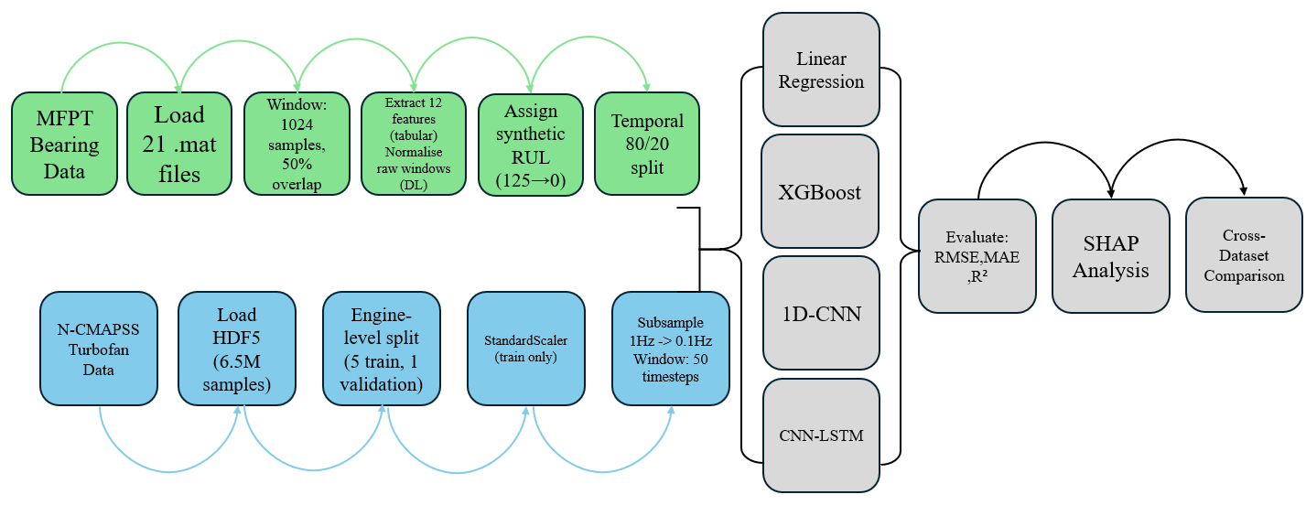
This study compares four models of increasingly complex design across two datasets. The experimental pipeline follows a structured sequence with 4 models being assessed across two datasets which will be trained and validated. The results will be evaluated with research backed metrics, and SHAP interpretability, then finally comparing how all models performed across both datasets. MFPT serves as the primary dataset as it contains real bearing fault data directly relevant to induction motor applications. N-CMAPSS serves as the validation dataset, providing large-scale turbofan engine data with run-to-failure trajectories that MFPT does not include. Because MFPT relies on synthetic Rul labels rather than measured run-to-failure degradation, N-CMAPSS provides a second environment with real RUL trajectories to confirm that the models are learning genuine degradation patterns and not just side-effects of the synthetic labelling.
Figure 1: Methodology Flowchart

3.2 Dataset 1: MFPT Bearing

3.2.1 Overview
The MFPT dataset was published by the Machinery Failure Prevention Technology Society and contains vibration recordings from bearings in three conditions: 3 baseline recordings from healthy bearings, 10 recordings with outer race faults, and 8 recordings with inner race faults, all captured at various load levels. The baseline signals were sampled at 48,828 Hz and the fault signals at 97,656 Hz, both from a single-channel accelerometer. This is directly relevant to induction motor bearings monitoring because accelerometers are the standard sensors used in industry for tracking bearing health.

3.2.2 Synthetic RUL Construction
MFPT does not provide run-to-failure data. The bearings were not run until they broke, snapshots were taken of bearings in different fault states instead. To make RUL prediction possible, synthetic labels were created by ordering the 21 recordings from healthiest to most degraded. Baseline recordings were given severity 0, outer race faults severity 1, and inner race faults severity 2. Within each severity level, recordings were ordered by load, with higher loads treated as more degraded. RUL values were then assigned linearly from 125 at the healthiest end down to 0 at the most degraded.
Each recording was sliced into windows of 1024 samples with 50% overlap, giving a step size of 512 samples. This produced 11,133 windows in total. The synthetic nature of these labels is a real limitation of this experiment, as the models learn to map vibration patterns to an assumed degradation order rather than to actual measured time-to-failure. This is discussed further in Section 5.6

3.2.3 Feature Engineering
For the machine learning models (Linear Regression and XGBoost), 12 features were calculated from each vibration window. These fall into two groups.
- Eight time-domain features capture what the vibration signal looks like statistically.
- RMS measures the overall vibration energy; Higher RMS correlates with more vibration.
- Peak amplitude is the single largest spike in the signal.
- Kurtosis measures how spiky the signal is; Healthy bearings produce smooth signals, whereas damaged bearings produce sharp impulses.
- Skewness measures whether the signal is lopsided.
- Crest factor is the ratio of peak to RMS, which gets larger the sharper impacts there are.
- Standard deviation measures how spread out the signal is.
- Mean absolute value captures average signal strength.
- Shape factor is the ratio of RMS to mean absolute value.

- Four Frequency-domain features capture what frequencies are present in the vibration.
- Spectral centroid shows where the centre of the frequency energy sits.
- Spectral RMS frequency measures how spread out the frequencies are.
- Spectral kurtosis detects whether there are impulsive frequency components.
- Peak frequency identifies the single strongest frequency. As bearing defects develop, they produce specific frequencies relate to the bearing geometry, so these features are physically meaningful.
For the deep learning models, the raw 1024-sample windows were normalised and fed in directly. The whole point of using a CNN is that it learns its own features, so hand-engineering them defeats the purpose.

3.3 Dataset 2: N-CMAPSS Turbofan

3.3.1 Overview
The NASA N-CMAPSS dataset DS02 (Arias Chao et al, 2020) was generated from a high-fidelity simulation of a turbofan engine. It contains 6,517,190 samples recorded at 1Hz from 9 engines: 6 for training (units 2,5,10,16,18,20) and 3 for testing (units 11,14,15).
There are 18 input features split into two groups.
- Four operating conditions describe what the engine is doing: altitude, Mach number, throttle resolver angle, and fan inlet temperature.
- Fourteen physical sensors measure what’s going on inside the engine: temperatures at four stations (T24, T30, T48, T50), pressures at six stations (P15, P21, P24, Ps30, P40, P50), fan and core speed (Nf,Nc), fuel flow (Wf), and fuel-air ratio (farB). This is a much richer feature set than MFPT’s single vibration channel, which is useful for testing whether the methodology works with different types of sensor data.
N-CMAPSS was chosen as the validation dataset because it is well-established in the research community with over 500 citations, its large-scale suits deep learning, and published results from other researchers provide benchmarks to compare against.

3.3.2 Failure Modes and Distribution Shift
The dataset includes two types of failure. Units 2, 5, and 10 suffer from High Pressure Turbine efficiency degradation only, single component failure. Units 16, 18, and 20 have a more complex failure involving both the HPT and Low Pressure Turbine degrading together.
On top of this, test engines 14 and 15 fly different profiles to the training engines, which perform shorter flights at lower altitudes. This introduces a distribution shift, testing whether the models can generalise for operating conditions they have not seen during training.

3.4 Preprocessing

3.4.1 MFPT Preprocessing
After windowing, the 12 engineered features were normalised using StandardScaler, which adjusts each feature to have zero mean and a standard deviation of one. The scaler was fitted only on the training data, then applied to the test data using the same parameters. If the scaler had been fitted on all the data including the test set, information about the test data would leak into the training process and make the results look better than they are. This is called data leakage.
The data was split 80/20 by time, using the first 8,906 windows for training and the last 2,227 for testing. The data was not shuffled. This matters because if shuffled, the model gets to see degraded windows during training that are almost identical to windows in the test set, which artificially improves performance. By keeping the time order, the model trains mostly on healthy data and must predict degradation it has barely seen. This is harder but more realistic, because in real-life applications training would use historical data and predict into the future.
For the deep learning models, each raw window was normalised independently and reshaped to add a channel dimension for the TensorFlow Conv1D input format

3.4.2 N-CMAPSS Preprocessing
Features were normalised with StandardScaler fitted on training data only, same principle as MFPT.
The data was split by engine rather than by individual timestep. Five engines went to training and one to validation. This is more rigorous than a random split because consecutive seconds from the same engine look almost identical, e.g. if second 500 and second 501 from the same engine end up in training and validation respectively, then the model can effectively cheat by memorising what that specific engine looks like rather than learning general degradation.
For deep learning, the data was subsampled from 1Hz to 0.1Hz by taking every 10th reading. This was necessary for 5 million samples because at 1Hz would be too much data to process as windows. The subsampled data was then sliced into windows of 50 timesteps, with each window covering 500 seconds of real engine operation. Windows never cross engine boundaries, so that the last readings from one engine are never combined with the first readings from another.

3.5 Evaluation
Three metrics were used to assess model performance.
- RMSE is the primary metric as it punishes large errors more than small ones.
- MAE gives the average error in plain units, which is easier to explain for those without knowledge of statistics.
- R² shows how much of the variation in RUL the model explains, where 1.0 is perfect and 0 means the model is no better than just guessing the average. Negative R² values, which appeared on the MFPT results, mean the model did worse than guessing the average.
To make the comparison between models fair, XGBoost was tested on the exact same windowed test samples that the CNN and CNN-LSTM used. Without this step, the DL models would be evaluated on different test data than XGBoost, making comparison unreliable. On N-CMAPSS, 5-fold cross-validation with GroupKFold gave a measure of how consistent XGBoost’s performance was across different engine combinations.

3.6 SHAP Analysis
SHAP was applied to XGBoost on both datasets to understand which features drive the predictions. For each prediction the model makes, SHAP works out how much each input feature pushed the predicted RUL up or down compared to the average. When you average this across thousands of predictions, you get a ranking of which features matter most overall.
The features were grouped by physical type: time-domain vs frequency-domain on MFPT, and sensor type vs operating conditions on N-CMAPSS. The point of doing this is to check whether the model is picking up on things that actually make physical sense. If SHAP says kurtosis is the most important bearing feature, that lines up with what engineers already know about bearing degradation. If it said something random like skewness was dominant, that would suggest the model might have learnt statistical noise rather than real patterns.

3.7 Computational Environment
All experiments ran on Kaggle GPU notebooks with dual NVIDIA Tesla T4 GPUs. Software used: Python 3.12, TensorFlow 2.x, scikit-learn, XGBoost with CUDA GPU acceleration, SHAP, NumPy, pandas and matplotlib.

Chapter 4: Proposed AI and ML Models

4.1 Linear Regression
Linear Regression is the simplest model tested, and relatively easy to implement. It takes the input features, multiplies each one by a learned weight, adds them up, and outputs an RUL prediction. It assumes that each feature has a straight-line relationship with remaining life, which is almost never true for bearing degradation where things interact in non-linearly. This acts as a baseline for complex deep learning models to beat, if they cannot then the complexity is not worth it.

4.2 XGBoost
XGBoost (Chen and Guestrin, 2016) builds a prediction by training decision trees one after another. Each tree is a set of if-then rules, e.g. if kurtosis is above 4.5 and RMS is below 0.3, then predict RUL to be 20. The first tree makes a rough guess, then the second tree looks at where the first tree was most wrong and focuses on correcting those mistakes. After 300 to 400 trees, the combined prediction is far better than any single tree could manage.
Nine different configurations were tested through a grid search over two settings: max_depth at 4, 6 and 8, which controls how many levels of rules each tree can have, and learning_rate at 0.05, 0.1 and 0.2, which controls how much each new tree contributes to prediction. Early stopping was used to automatically prevent adding trees once the model stopped improving on the validation data. On N-CMAPSS, 5-fold cross-validation with GroupKFold was used, making sure each fold contained whole engines rather than random timesteps.

4.3 1D-CNN
The 1D-CNN works by sliding small filters across the input signal. Each filter learns to detect a specific local pattern, e.g an impulse from a bearing defect or a frequency shift from cage wear. The network does not need to be told what patterns to look for, instead it learns during training.
The architecture has three convolutional blocks, and each block does four things. Conv1D applies the filters to detect patterns. BatchNormalization keeps the numbers flowing through the network well-scaled so that training stays stable. MaxPooling compresses the time dimension by keeping only the strongest signal in each region, which reduces the amount of computation needed. Dropout randomly switches off 20% of the neurons during each training step, which forces the network to spread its learning across many neurons rather than relying on just a few, preventing memorising training data.
After the three blocks, GlobalAveragePooling takes the average across whatever time dimension is left, producing a single fixed-length summary of the entire window. Two Dense layers then convert this summary into a final RUL number. The MFPT experiment uses wider filters (sizes 16, 8 and 4) because the vibration windows are 1024 samples long and need broader pattern detection. The N-CMAPSS experiment uses narrower filters (5,3 and 3) for the shorter 50-timestep windows. Total trainable parameters: 106,881 for MFPT and 62,465 for N-CMAPSS

4.4 CNN-LSTM Hybrid
The CNN-LSTM model uses the same first two convolutional blocks as the 1D-CNN to extract local patterns. But instead of a third convolutional block and GlobalAveragePooling, the output is fed into two stacked LSTM layers.
The first LSTM has 64 units and processes the CNN output step by step, carrying a memory state forward. At each step it decides what to remember and what to forget from previous steps. The second LSTM has 32 units and does the same thing on the first’s output, producing a single vector that summarises how the patterns changed across the entire window.
The idea is that the CNN finds what patterns exist at each point in the signal, and the LSTM tracks how those patterns evolve over time. For bearing data this could theoretically detect things like kurtosis gradually increasing across a window, which would suggest worsening damage. Dense layers then turn the LSTM output into an RUL prediction. Total parameters: 130,433 for MFPT and 94,209 for N-CMAPSS.

4.5 Training Configuration
All deep learning models used the Adam optimiser starting with a learning rate of 0.001. Adam adjusts the learning rate for each parameter individually based on how the training has been going, which helps when different features are on different scales.
The loss function was Mean Squared Error, which is directly related to the main evaluation metric, RMSE. Two callbacks controlled the training process.
ReduceLROnPlateau halves the learning rate if the validation loss has not improved for 5 epochs in a row, letting the model make finer adjustments.
EarlyStopping stops training completely if there is no improvement for 10 epochs, then loads the weights from whichever epoch had the best validation performance.
This stops the model from training too long and memorising the training data instead of general patterns, which is called overfitting.
Batch size was 64 for MFPT and 256 for N-CMAPSS. Random seeds were set to 42 for both TensorFlow and NumPy to make the results reproducible, though small variations between runs are expected due to some GPU operations in TensorFlow being not perfectly deterministic.

Chapter 5: Results and Analysis

5.1 Testing on Dataset 1: MFPT Bearing: Exploratory Data Analysis
Before training any models, the 12 engineered features were checked for how strongly each one correlated with RUL. The strongest correlation was spectral kurtosis at |r| = 0.46, followed by crest factor at 0.41 and shape factor at 0.40, as seen in Figure 2 below. These are moderate correlations, and the strongest feature only explains about 21% of the variance in RUL (0.46 squared). Time-domain features and frequency-domain features were roughly equal in their average correlation strength, both around |r| = 0.26.
This implies that no single feature is good enough to predict bearing RUL on its own. A traditional threshold-based monitoring system that triggers an alarm when one feature crosses a set value would miss the majority of the degradation information available. This is one of the main motivations for using machine learning and deep learning, which can combine all 12 features together and find patterns between them that individual features cannot show.
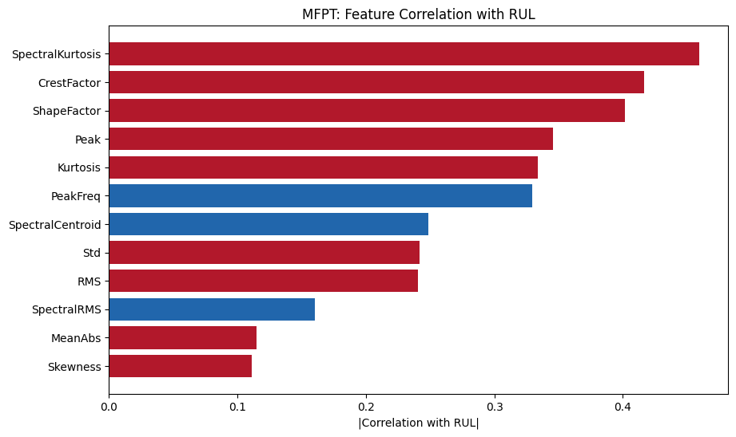
Figure 2: MFPT feature correlation bar chart

5.2 Testing on Dataset 1: MFPT Bearing: Linear Regression
Linear Regression achieved RMSE of 78.58, MAE of 62.58, and R² of -117.49. The negative R² means the model performed worse than simply predicting the average RUL for every single window. This might sound like complete failure, but it is expected given the temporal train-test split. The model trained on data where RUL ranged roughly from 125 down to 25, then was tested on data where RUL ranged from 25 down to 0. It had to extrapolate into a degradation regime it had barely seen during training, and a straight-line model cannot handle that kind of extrapolation.
The scatter plot in Figure 3 shows this clearly as predictions appear wildly scattered, with many going negative (which is physically impossible for RUL). This establishes the baseline that more complex models will need to beat. If not, then added complexity isn’t justified.
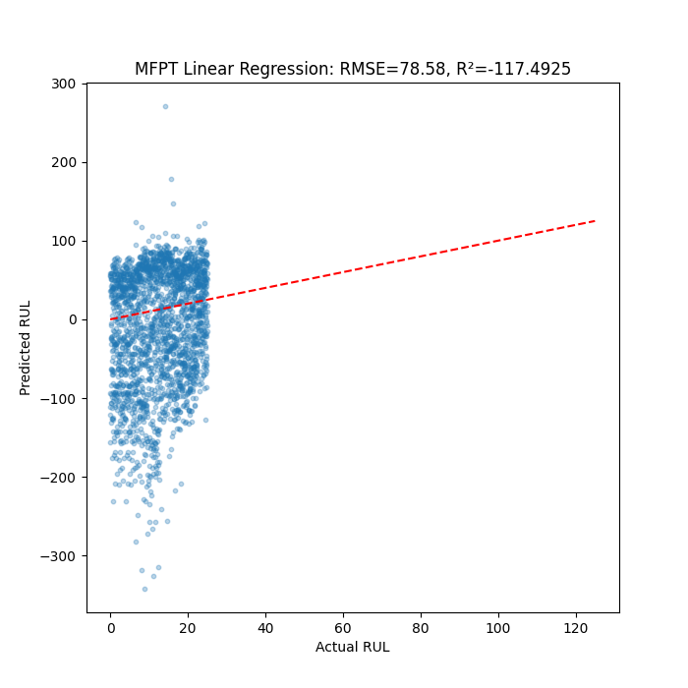
Figure 3: MFPT LR scatter plot

5.3 Testing on Dataset 1: MFPT Bearing: XGBoost
The 3x3 grid search tested nine combinations of max_depth and learning_rate. The best configuration achieved RMSE of 30.39, a 61.3% improvement over Linear Regression. R² was still negative at -16.72, meaning it still underperformed mean prediction in absolute terms, but the RMSE reduction shows that XGBoost captured non-linear relationships between the vibration features and Rul that Linear regression could not.
The XGBoost feature importance ranking, shown in the right panel of Figure 4, identified kurtosis as the single most important feature, followed by peak frequency and mean absolute value. This is physically valid as kurtosis is a well-known indicator of bearing surface damage. The learning curves in the middle panel show training RMSE dropping steadily while test RMSE plateaus around 30, indicating the model learned what it could from the engineered features but could not push further. The gap between training and test curves suggests some overfitting to the training data, which is expected given the challenging temporal split where training and test data come from different fault conditions.
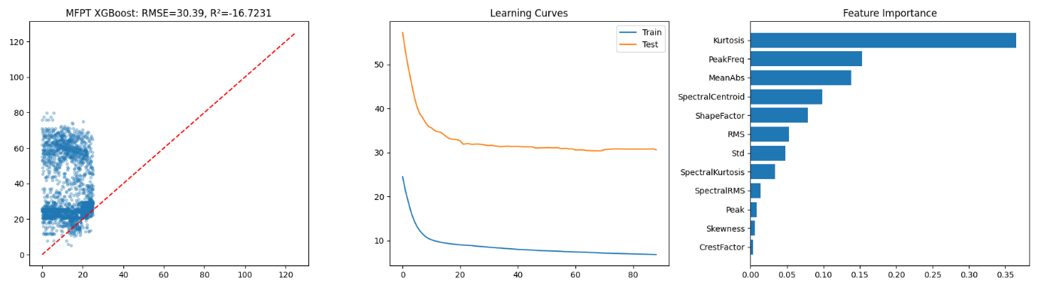
Figure 4: MFPT XGBoost three-panel (scatter, learning curves, feature importance)

5.4 Testing on Dataset 1: MFPT Bearing: 1D-CNN
The 1D-CNN achieved RMSE of 11.60, MAE of 9.78, and R² of -1.58. This is a 61.8% improvement over XGBoost, the largest single improvement of any model transition in the entire study. While R² is still negative due to the challenging temporal split, the RMSE of 11.60 represents a genuine prediction capability.
The significance of this result is that the CNN learned degradation patterns directly from the raw vibration signal that the 12 hand-engineered features could not capture. Those 12 features were specifically chosen because they are established bearing condition indicators used in industry. Yet the CNN, working from the raw signal with no guidance, found additional information that improved prediction by over 60%. This suggest that bearing degradation produces subtle patterns in the vibration waveform that standard statistical features miss.
The loss curves in Figure 5 show training continuing to decrease while the validation loss begins to rise after the first few epochs, with the two curves moving in opposite directions. This is a sign of overfitting, where the model got better at memorising the training data but worse at predicting unseen data. This is expected given that the model has 106,881 parameters but only 8,906 training windows, which is a lot of model for not much data. EarlyStopping caught this by selecting the weights from the epoch where validation loss was lowest, before the divergence got worse. The residual histogram shows a mean error of -9.35, indicating the CNN systematically underpredicts RUL. For maintenance purposes this is the safer direction to make errors in, as it leads to earlier intervention rather than missed failures.
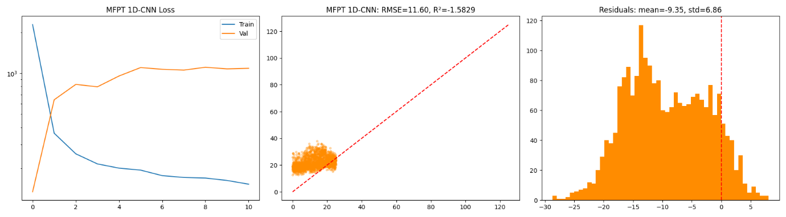
Figure 5: MFPT CNN three-panel (loss curves, scatter, residuals)

5.5 Testing on Dataset 1: MFPT Bearing: CNN-LSTM
The CNN-LSTM achieved RMSE of 13.90, MAE of 11.87, and R² of -2.71. Despite having 130,433 parameters compared to the CNN’s 106,881 and taking approximately the same training time, it performed 19.8% worse than the standalone CNN.
This result directly answers RQ2 for bearing data: the LSTM layers did not help. Looking at the loss curves in Figure 6, training loss dropped lower than the CNN’s, suggesting the model had enough capacity to fit the training data well. But validation loss was higher, meaning the extra parameters learned patterns specific to the training data rather than general degradation patterns. The scatter plot (fig 6) shows predictions clustered in a similar range to the CNN but with more spread, and the residual histogram shows a positive mean error of 8.95, meaning the CNN-LSTM tends to overpredict RUL, the opposite bias to the CNN and the more dangerous direction for maintenance, as it could lead to missed failures.
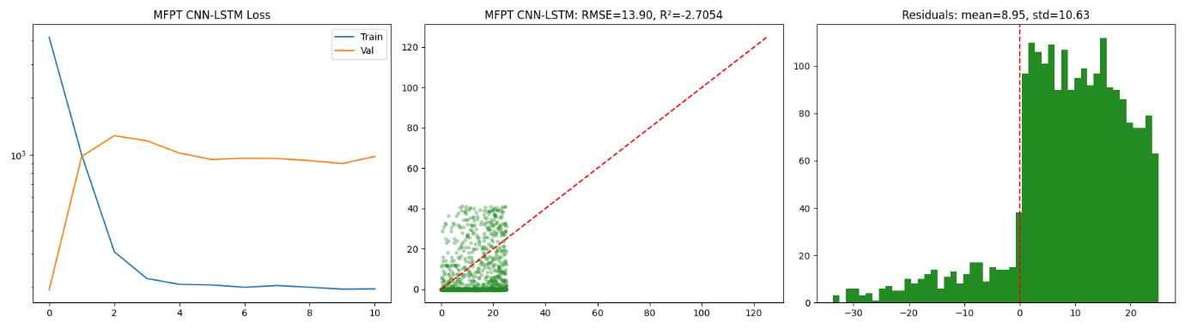
The bearing degradation signal in these 1024-sample vibration windows appears to manifest as distributional changes rather than as complex temporal sequences. The LSTM’s ability to remember what happened earlier in the sequence adds nothing when the degradation information is already captured by the CNN’s pattern detection within the local regions of the signal.
Figure 6: MFPT CNN-LSTM three-panel (loss curves, scatter, residuals)

5.6 Testing on Dataset 1: MFPT Bearing: Model Comparison
Table 2 summarises the performance of all four models on the MFPT bearing dataset. The progression from Linear Regression through XGBoost to CNN shows massive improvement at each step. The CNN-LSTM breaks this pattern by performing worse than the CNN despite being more complex
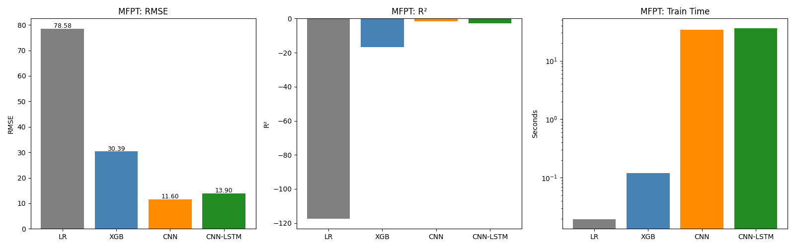
This tells a clear story about what kind of information matters for bearing RUL prediction. Linear Regression can only use linear relationships between individual features and RUL. XGBoost can capture non-linear interactions between features but still processes each window independently. The CNN can detect temporal patterns within the raw vibration signal that neither LR nor XGBoost can see. But the CNN-LSTM’s additional sequential memory does not help because the relevant patterns are local rather than sequential
Figure 7: MFPT comparison bar chart

Table 2: MFPT model comparison (RMSE, MAE, R², time, parameters)
Model | RMSE | MAE | R² | Time | Parameters
Linear Regression | 78.58 | 62.58 | -117.49 | <0.1s | 13
XGBoost | 30.39 | 23.89 | -16.72 | 0.1s | 400 trees
1D-CNN | 11.60 | 9.78 | -1.58 | ~60s | 106,881
CNN-LSTM | 13.90 | 11.87 | -2.71 | ~60s | 130,433

5.7 Testing on Dataset 1: MFPT Bearing: SHAP Analysis
SHAP analysis on the XGBoost model revealed kurtosis as the dominant predictor of bearing RUL, as shown in Figures 8 and 9. Shape factor and spectral centroid were the next most important features, followed by peak frequency and standard deviation. Both time-domain and frequency-domain features contributed meaningfully, with no single domain dominating.
The dominance of kurtosis is physically meaningful and provides confidence that the model learned genuine degradation patterns rather than statistical noise. In bearing condition monitoring, kurtosis is one of the most established indicators of surface damage. As defects develop on the raceway surface, each time the rolling element passes over the defect it produces a sharp impulse that increases kurtosis dramatically. The fact that the XGBoost model independently identified this as its most important feature validates that the model is learning real degradation patterns from the synthetic RUL labels.
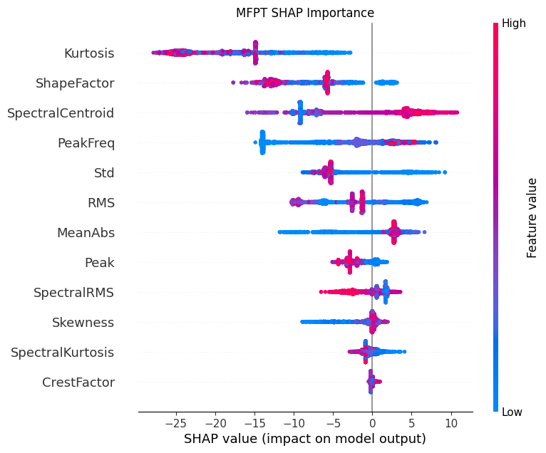
The SHAP beeswarm plot in Figure 8 shows that higher kurtosis values consistently push the predicted RUL lower (towards more degraded), which matches the physical expectation. Shape factor’s importance suggests the model also captured changes in the overall waveform shape that accompany bearing wear.
Figure 8: MFPT SHAP beeswarm plot

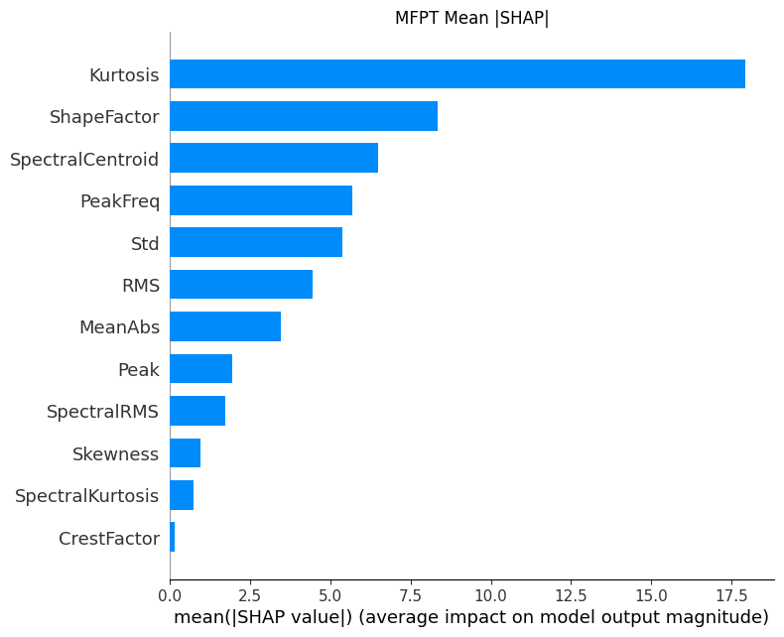
Figure 9: MFPT SHAP bar chart

5.8 Testing on Dataset 2: N-CMAPSS Turbofan: Results
To confirm that the methodology works beyond the MFPT bearing dataset, all four models were applied to the NASA N-CMAPSS turbofan engine dataset. As described in Section 3.1, N-CMAPSS provides a fundamentally different validation environment.
Linear Regression achieved RMSE of 11.81 and R² of 0.6123. The positive R² here, compared to the severely negative values on MFPT, reflects the fact that the N-CMAPSS test set spans the full RUL range rather than being limited to the most degraded end.
XGBoost achieved RMSE of 9.26 and R² of 0.7618, a 21.6% improvement over LR. 5-fold cross-validation with the engine-level grouping produced a mean RMSE of 9.95 ±2.08, indicating consistent but not identical performance across different engine combinations. The variance reflects genuine differences in how individual engines degrade.
The 1D-CNN achieved RMSE of 5.85 and R² of 0.9046, a 36.8% improvement over XGBoost. This is lower than the 61.8% improvement seen on MFPT, but still substantial. Both the CNN and XGBoost were also compared on identical windowed test samples to ensure fairness, with XGBoost scoring 9.24 on the same data. This confirms that the CNN’s advantage is real and not a side-effect of different test samples.
The CNN-LSTM achieved RMSE of 5.81 and R² of 0.9059, marginally better than the CNN by 0.7%. This is essentially a tie; there was slight difference in run-to-run variation caused by GPU non-determinism. On MFPT the CNN-LSTM was 19.8% worse than the CNN, but on N-CMAPSS it performed comparably. This suggests that the LSTM layers hurt performance on smaller single-channel datasets but are neutral when sufficient multi-sensor data is available.
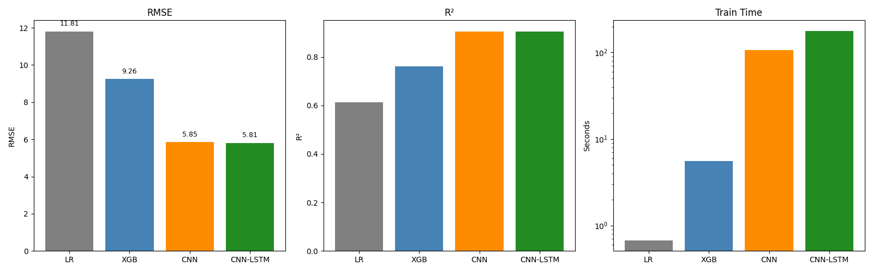
The core finding holds across both datasets: deep learning consistently and substantially outperformed traditional machine learning. The CNN improved over XGBoost by 37-62% depending on the dataset. Arias Chao et al. (2020) reported RMSE of 12-15 using physics-based methods on N-CMAPSS, and both the CNN (5.85) and CNN-LSTM (5.81) more than halved this, demonstrating that data-driven approaches outperform physics-based modelling when sufficient training data is available.
Figure 10: N-CMAPSS comparison bar chart

Table 3: N-CMAPSS model comparison
Model | RMSE | MAE | R² | Time | Parameters
Linear Regression | 11.81 | 10.16 | 0.6123 | 0.7s | 19
XGBoost | 9.26 | 7.21 | 0.7618 | 5.7s | 300 trees
1D-CNN | 5.85 | ~4.27 | 0.9046 | 131s | 62,465
CNN-LSTM | 5.81 | ~4.24 | 0.9059 | 280s | 94,209
XGBoost (windowed) | 9.24

5.9 Testing on Dataset 2: N-CMAPSS Turbofan: SHAP and Error Analysis
SHAP analysis on the N-CMAPSS XGBoost model identified T24, the compressor outlet temperature, as the single most important feature at 29% of total importance. P50, the turbine outlet pressure, contributed 20.2%, followed by Mach number at 8.4% and core speed (Nc) at 8.3%. Physical sensors collectively accounted for 83.4% of predictive importance versus 16.6% for operating conditions, and temperature sensors specifically contributed 33.1%.
These results make physical sense. T24 rises as the compressor blades wear and efficiency drops, requiring higher temperatures to maintain the same pressure ratio. P50 reflects coupled turbine degradation downstream. The fact that sensors dominated over operating conditions confirms the model is reading actual degradation signals rather than memorising flight profiles.
Comparing the two dataset’s SHAP results: on MFPT, kurtosis (a vibration distribution metric) was dominant, while on N-CMAPSS, T24 (a temperature measurement) was dominant. These are completely different features from different sensor types, but both are physically meaningful degradation indicators for their respective equipment. This provides confidence that the methodology learns genuine physics-based patterns regardless of the specific sensor type.
Error analysis on N-CMAPSS XGBoost by RUL range revealed an unexpected pattern. End-of-life predictions (RUL 0-10 cycles) had the lowest RMSE at 3.69, mid-life (10-40) had the highest at 10.33, and early life (40+) was intermediate at 9.54. This means the model is most accurate when the engine is close to failure and maintenance decisions would be more urgent. Mid-life is hardest because engines degrade at different rates under different operating conditions, making precise prediction in this range inherently more uncertain.
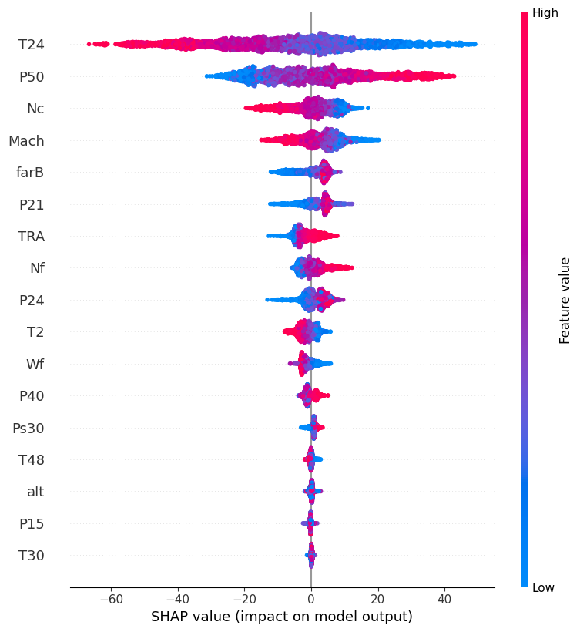
Figure 11: N-CMAPSS SHAP beeswarm

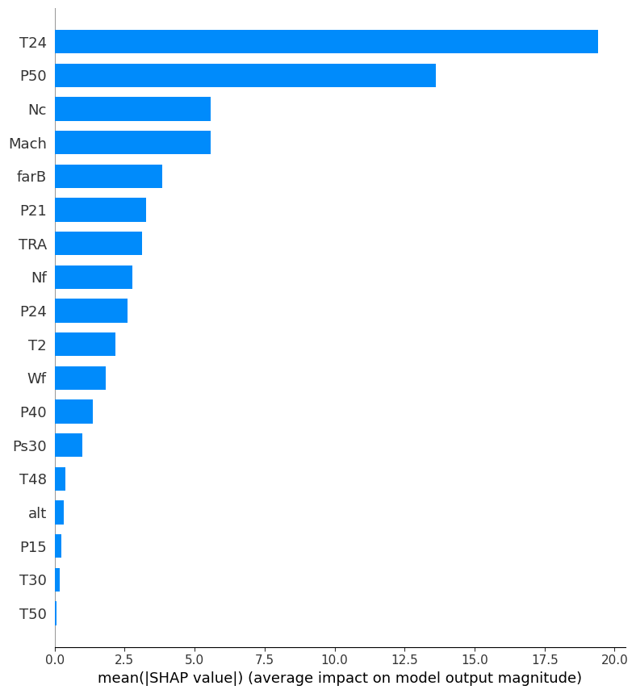
Figure 12: N-CMAPSS SHAP bar chart
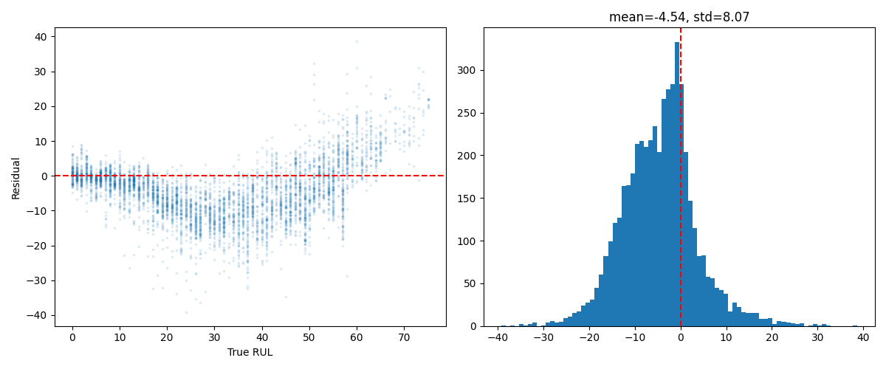
Figure 13: N-CMAPSS error analysis

5.10 Cross-Dataset Comparison
Table 4 below represents the model rankings side by side across both datasets. Deep learning models occupy the top two positions on both datasets, with traditional ML in third and fourth. The CNN ranked first on MFPT and second on N-CMAPSS, while the CNN-LSTM ranked second on MFPT and first on N-CMAPSS. The difference between CNN and CNN-LSTM on N-CMAPSS is only 0.7%, well within run-to-run variation, while on MFPT the CNN’s advantage was a clear 19.8%.
The CNN’s improvement over XGBoost was larger on MFPT (62%) than on N-CMAPSS (37%), suggesting that temporal learning from raw vibration data is even more valuable than temporal learning from multi-sensor tabular data. This makes sense as the 12 hand-engineered MFPT features already captured much of the non-temporal information, so the CNN’s advantage came specifically from temporal patterns in the raw signal. On N-CMAPSS, the 18 sensor features already contained more information per timestep, leaving less room for temporal modelling to add value.
The consistent finding across both datasets is that deep learning provides substantial improvement over traditional ML for RUL prediction, and that CNN-LSTM does not meaningfully improve over a standalone CNN for the data structures and window sizes tested. This validates the methodology’s applicability across both bearing fault data and turbofan degradation data, answering RQ3.
Table 4: Cross-dataset ranking comparison
Rank | MFPT Bearing | RMSE | N-CMAPSS Turbofan | RMSE
1st | 1D-CNN | 11.60 | CNN-LSTM | 5.81
2nd | CNN-LSTM | 13.90 | 1D-CNN | 5.85
3rd | XGBoost | 30.39 | XGBoost | 9.26
4th | Linear Regression | 78.58 | Linear Regression | 11.81

Chapter 6: Discussion

6.1 Interpretation of MFPT Bearing Results
The MFPT results directly answer RQ1: deep learning substantially outperforms traditional machine learning for bearing RUL prediction. The CNN achieved 62% lower RMSE than XGBoost, which itself was already 61% better than Linear Regression. Each step up in complexity unlocked new information, from linear relationships through non-linear feature interactions to temporal patterns in raw vibration
The negative R² values on all MFPT models do not mean the models failed. They are a direct result of the train-test split, where models trained mostly on healthy data were tested exclusively on the most degraded windows. The relative improvements between models are the meaningful comparison, not the absolute R² values. A model that achieves RMSE of 11.60 is genuinely useful for maintenance even if it’s R² is technically negative, because it is predicting RUL values in the roughly correct range rather than producing the wildly scattered outputs seen from Linear Regression.
The fact that SHAP identified kurtosis as the dominant feature is important because it validates the experiment despite the synthetic Rul labels. Kurtosis is a well-established bearing degradation indicator and engineers have known for decades that damaged bearings produce spikier vibration. The model was never given this information and was able to work this out from raw data alone, which gives confidence that the CNN is learning genuine degradation patterns rather than fitting noise into synthetic labels.

6.2 N-CMAPSS Turbofan results confirm the core finding
The same methodology applied to N-CMAPSS produced the same core finding: deep learning dramatically outperforms traditional machine learning for RUL prediction. CNN and CNN-LSTM both achieved approximately 37% improvement over XGBoost on N-CMAPSS, compared to 62% on MFPT. The improvement is smaller on N-CMAPSS because the 18 sensor features already contain more degradation information per timestep than MFPT’s single vibration channel, so there is less room for temporal modelling to add value.
The fact that CNN and CNN-LSTM performance was identical on N-CMAPSS (5.85 vs 5.81) while the CNN clearly won on MFPT (11.60 vs 13.90) reveals something useful about when LSTM layers help. The LSTM layers were harmful on small data and neutral on large data, which means that there was no instance where LSTM layers were beneficial.
Most bearing RUL studies use only one dataset, making dataset-specific results indistinguishable from general findings. By showing consistent results across bearing vibration data and turbofan multi-sensor data, this project provides evidence that the CNN’s advantage is a general finding rather than an anomaly of the MFPT dataset.

6.3 Comparison with Conventional Methods
Threshold-based monitoring triggers alarms when a single sensor crosses a set value. The EDA results from both experiments shows why this is insufficient. On MFPT, the best individual feature correlation was |r| = 0.46 for spectral kurtosis, meaning a single-feature threshold captures less than a quarter of the available degradation information. On N-CMAPSS, individual sensor correlations were even weaker at |r| = 0.13, making single-sensor thresholds essentially useless for multi-condition turbofan data. The CNN captures all this information simultaneously and finds temporal patterns on top of it.
Physics-based models are the most sophisticated conventional approach. Arias Chao et al. (2020) achieved RMSE of 12-15 on N-CMAPSS using thermodynamic equations derived from first principles. Both the CNN (5.85) and CNN-LSTM (5.81) more than halved this, demonstrating that data-driven methods outperform physics-based modelling when sufficient training data is available. No equivalent physics-based benchmark exists for the MFPT dataset, which limits the comparison for induction motor applications which is addressed for future work in Section 6.3.
The progressive improvement from conventional methods provides a clear evidence hierarchy. Each step adds capability: threshold monitoring uses one feature, XGBoost uses all features with non-linear interactions, and CNN adds temporal pattern recognition. The question for industrial deployment is whether the accuracy improvement at each step justifies the computational cost.

6.4 Why CNN-LSTM Did not improve over CNN
This is one of the most interesting findings of the project because the literature generally presents hybrid architectures as superior to single-architecture models. The results here tell a different story.
On MFPT, the CNN-LSTM was 19.8% worse than the standalone CNN. On both datasets, the LSTM received sufficient timesteps after pooling but still failed to find patterns the CNN missed. But the bearing degradation signal in these windows appears as distributional changes, rather than as complex sequences where the order of events matters. The extra parameters increased overfitting risk without capturing additional information, as the overfitting in Figure 6 confirmed.
On N-CMAPSS, the CNN-LSTM was 0.7% better, which essentially a tie. With the larger dataset of 300,000 training windows and 18 features per timestep, there was enough data to train the extra parameters without overfitting. But even with sufficient data, the LSTM still could not find temporal patterns that the CNN missed. The degradation signal at 0.1Hz sampling appears to show up as shifted distributions within windows rather than as complex sequential narratives that need memory to decode.
This directly answers RQ2: the hybrid CNN-LSTM does not provide significantly improved RUL prediction over a standalone CNN for the bearing data and another rotary dataset in this project. The practical implication for induction motor deployment is straightforward, which is to use the simpler 1D-CNN. It is faster to train, has fewer parameters, and performs equal to or better than the hybrid on every dataset tested.

6.5 Transferability to Induction Motor Applications
The MFPT experiment already uses bearing fault data, which is directly relevant to induction motors. Accelerometer-based vibration monitoring is standard practise for industrial motor bearings, and the CNN pipeline processes raw vibration signals directly with no modification needed for different bearing types of motor configurations. An engineer could take the same code, point it at vibration data from an induction motor bearing, and run it without changing the architecture.
The SHAP results support transferability at a deeper level. On MFPT, the model identified kurtosis as the dominant degradation indicator. On N-CMAPSS, it identified T24 (temperature) as dominant. These are completely different features from different sensor types, but both are physically meaningful indicators of degradation for their respective equipment. This shows the methodology does not depend on a specific sensor type. For an induction motor with both vibration and temperature sensors, the pipeline would work on either or both.
The remaining gap is that MFPT uses synthetic RUL labels, not measured run-to-failure degradation. The models may be learning fault severity classification (healthy vs outer race vs inner race) rather than true remaining life prediction. Validation on a genuine run-to-failure bearing dataset such as IMS or PRONOSTIA would close this gap and provide stronger evidence that the CNN can track progressive degradation than just classifying fault states. This is recommended as a priority for future work.

6.6 Limitations
The MFPT data includes time-series data but not run-to-failure, so synthetic RUL labels are a proxy for actual degradation. The linear assignment from 125 to 0 assumes that degradation progresses uniformly from healthy through outer race fault to inner race fault, ordered by load within each category. In reality, bearing degradation is non-linear and load alone does not determine how degraded a bearing is. The models may be learning to classify fault severity rather than predict genuine remaining useful life.
The N-CMAPSS validation used a single engine for the validation set, which produced volatile validation loss during deep learning training. EarlyStopping decisions based on a single engine’s data may not be optimal, and a different validation engine could have produced different stopping points and therefore different results.
Data was subsampled from 1Hz to 0.1Hz on N-CMAPSS, discarding 90% of the temporal resolution. The effect of finer sampling rates on model performance, particularly on whether LSTM could demonstrate advantage with more temporal detail, was not investigated.
The two N-CMAPSS failure modes (HPT only versus HPT+LPT combined) were not analysed separately. All test engines had the complex failure mode, and the training set contained a mix. Whether model performance differs between failure types is unknown.
The XGBoost hyperparameter grid search on both datasets evaluated configurations against the test set rather than a held-out validation set, which may introduce mildly optimistic bias into the reported XGBoost RMSE values.
Finally, the 0.7% difference between CNN and CNN-LSTM on N-CMAPSS falls within the range of run-to-run variation caused by GPU non-determinism in TensorFlow. Without running the experiment multiple times and performing statistical significance testing, it is not possible to say with certainty that either architecture is genuinely superior on this dataset. A re-run could plausibly reverse their ranking.

6.7 Industry Implications
For induction motor bearing monitoring, the results point to a clear recommendation: deploy a 1D-CNN on raw accelerometer vibration data. It outperformed XGBoost by 62% on bearing data, does not require manual feature engineering, and proved more effective than the more complex CNN-LSTM. The simplicity of the CNN compared to the hybrid also means lower computational requirements for edge deployment on industry 4.0 monitoring systems.
SHAP analysis provides actionable sensor guidance for both equipment types. For bearing applications, vibration kurtosis should be prioritised as the primary monitoring feature. For turbofan-type applications with multiple sensors, temperature monitoring is most informative. These findings can help organisations decide which sensors to invest in when designing new condition monitoring systems.
The consistent finding that CNN-LSTM did not improve significantly over CNN suggests that practitioners should not default to the most complex available architecture. Instead, the choice of model should be guided by the specific data characteristic: dataset size, number of sensors, and the nature of the degradation signal.

Chapter 7: Conclusions, contributions and future work

7.1 Summary of Achievements
This project set out to apply deep learning methods to predict the Remaining Useful Life of induction motor bearings, and to validate the methodology across different equipment types. Six objectives were defined and all were achieved.
O1 was completed through a literature review of 25 bearing RUL studies, which identified three gaps: the near-total absence of ML baselines in DL studies, the lack of cross-equipment transferability testing, and the neglect of model interpretability. These gaps directly shaped the experimental design
O2 was achieved by preparing both datasets for experimentation. The MFPT bearing dataset produced 11,133 windows with 12 hand-engineered vibration features. The N-CMAPSS turbofan dataset provided 6.5 million samples with 18 sensor features. Linear Regression and XGBoost baselines were established on both.
O3 was achieved through the 1D-CNN, which delivered the best performance on MFPT bearing data (RMSE 11.60, 62% improvement over XGBoost) and strong results on N-CMAPSS (RMSE 5.85, 37% over XGBoost). Both results outperform the physics-based RMSE of 12-15 reported by Arias Chao et al. (2020) on N-CMAPSS.
O4 was achieved by implementing the CNN-LSTM hybrid on both datasets. It underperformed the CNN on MFPT (RMSE 13.90 vs 11.60) and performed comparably on N-CMAPSS (5.81 vs 5.85). This demonstrates that recurrent complexity is not justified for bearing RUL prediction with the data structures tested.
O5 was achieved through SHAP analysis on both datasets. Kurtosis was identified as the dominant bearing feature and T24 (temperature) as the dominant turbofan feature, both corresponding to established degradation physics.
O6 was achieved through the cross-dataset comparison, which showed deep learning consistently outperforming traditional ML on both bearing and turbofan data. The CNN is recommended for bearing applications based on its clear superiority on MFPT.

7.2 Contributions
This project makes four specific contributions to the field of bearing RUL prediction.
First, it provides one of the few systematic comparisons between traditional ML and deep learning on bearing data, addressing the gap identified in the literature review where only 4 of 25 studies included ML baselines.
Second, it offers empirical cross-dataset validation between bearing fault data and turbofan degradation data, which no previous study has attempted.
Third, it applies SHAP interpretability analysis to bearing RUL prediction and validates the results against known degradation physics, in a field where only 1 of 25 reviewed studies included such analysis.
Fourth, it provides evidence that hybrid CNN-LSTM architectures do not improve over standalone CNNs for bearing vibration data, a finding that publication bias in the literature typically suppresses.

7.3 Key Conclusions
Four principal conclusions emerge from this work
First, data-driven approaches substantially outperform conventional maintenance strategies. The CNN achieved 37-62% lower RMSE than XGBoost across both datasets, and more than halved the physics-based benchmark on N-CMAPSS. Time-based replacement and single-sensor threshold monitoring were shown to be fundamentally insufficient for the multi-feature, multi-condition data examined.
Second, temporal modelling through CNN is the critical step. The 37-62% improvement over XGBoost demonstrates that degradation information lives in temporal patterns within vibration windows, not in instantaneous feature values. This is the largest performance gain in the entire pipeline.
Third, CNN-LSTM adds complexity without benefit for bearing data. The LSTM layers hurt performance on MFPT (19.8% worse) and provided negligible improvement on N-CMAPSS (0.7% better, within run-to-run variation). For induction motor bearing applications, the simpler CNN is the recommended architecture.
Fourth, the methodology transfers across equipment types. The same pipeline produced strong results on single-channel bearing vibration and multi-sensor turbofan data without equipment-specific modifications, with physically meaningful SHAP features identified on both datasets.

7.4 Recommendations for Future Work
Several directions for future research emerge from the limitations of this project.
The more important next step would be validating the CNN on a genuine run-to-failure bearing dataset such as IMS or PRONOSTIA, replacing the synthetic MFPT RUL labels with measured degradation trajectories. This would confirm whether the CNN can track progressive bearing degradation rather than classifying fault severity. A physics-based bearing degradation model applied to MFPT would also provide an additional baseline, similar to how Arias Chao et al. (2020) benchmarked physics-based methods on N-CMAPSS.
Implementing a proper three-way train/validation/test split on MFPT or using a larger bearing dataset where such a split is feasible, would address the limitation of using the test set for validation during deep learning training.
Investigating finer N-CMAPSS subsample rates (0.2Hz, 0.5Hz) and longer windows would test whether the LSTM can demonstrate advantage with greater temporal context, since the current 0.1Hz subsampling and 50-timestep windows may not provide sufficient sequence length for recurrent modelling.
Attention mechanisms and transformer architectures should be explored as alternatives to LSTM for temporal modelling. Lightweight quantised CNN models suitable for edge deployment on industrial IoT bearing monitors would bring the methodology closer to practical application. Finally, uncertainty quantification through Monte Carlo dropout would provide confidence intervals for risk-aware maintenance scheduling.

7.5 Final Remarks
One of the things that surprised the author most about this project was the sheer number of gaps in the research around preventing waste in industrial maintenance. For a problem that costs industry hundreds of thousands of dollars per hour in downtime, the literature has remarkably few studies that actually compare whether deep learning is worth the added complexity over simpler methods. Only 4 of the 25 studies reviewed even included a machine learning baseline.
What also struck the author was the overwhelming number of possible configurations. There are dozens of model architectures, multiple sensor types, and countless small decisions like window size, subsample rate, dropout percentage, and early stopping patience that all affect the result. Finding the true optimum combination feels practically impossible, and it is suspected most published results represent one point out of untested alternatives
Perhaps the most important thing taken away from this project is a concern about validation. With AI becoming more capable, there is a growing risk that models get deployed because they produce good results without anyone checking whether what they leaned makes physical sense. The CNN in this project identified kurtosis as the dominant bearing feature, which engineers already know matters. But it could just as easily have learned a statistical pattern with no physical basis, and without SHAP analysis nobody would have known the difference. CNNs are genuinely valuable for revealing unforeseen patterns and interactions between sensors, but those patterns should be a starting point for further scientific investigation, not an endpoint that goes unquestioned because the RMSE looks sound.

References:
Arias Chao, M., Kulkarni, C., Goebel, K. and Fink, O. (2020) 'Aircraft Engine Run-to-Failure Dataset Under Real Flight Conditions for Prognostics and Diagnostics', Data, 6(1), p. 5.
Behera, S. and Misra, R. (2023) 'A multi-model data-fusion based deep transfer learning for improved remaining useful life estimation for IIOT based systems', Engineering Applications of Artificial Intelligence, 123, pp. 1–15.
Bisoyi, S., Rathi, A.K. and Mahato, S. (2024) 'Improvements in Prediction of Remaining Useful Life of Roller Bearings Using Deep Learning Models', International Conference on System Reliability and Safety, pp. 1–10.
Breiman, L. (2001) 'Random Forests', Machine Learning, 45(1), pp. 5–32.
Chen, T. and Guestrin, C. (2016) 'XGBoost: A Scalable Tree Boosting System', Proceedings of the 22nd ACM SIGKDD International Conference on Knowledge Discovery and Data Mining, pp. 785–794.
Cosin, R., Ribeiro, L.S.F. and Branco, K. (2023) 'Bearing Failure Prognostics Using Recurrent Neural Networks: A Spectral Data Based Architecture', SIBGRAPI Conference on Graphics, Patterns and Images, pp. 1–6.
Deloitte (2017) Making Maintenance Smarter. Deloitte University Press.
Deng, Y., Du, S., Wang, D., Shao, Y. and Huang, D. (2023) 'A Calibration-Based Hybrid Transfer Learning Framework for RUL Prediction of Rolling Bearing Across Different Machines', IEEE Transactions on Instrumentation and Measurement, 72, pp. 1–14.
Desai, P.S., Granja, V. and Higgs, C. (2021) 'Lifetime Prediction Using a Tribology-Aware, Deep Learning-Based Digital Twin of Ball Bearing-Like Tribosystems in Oil and Gas', Processes, 9(6), p. 922.
Fan, Y., Nowaczyk, S. and Rögnvaldsson, T.S. (2019) 'Transfer learning for Remaining Useful Life Prediction Based on Consensus Self-Organizing Models', Reliability Engineering and System Safety, 203, p. 107098.
IEEE (2007) IEEE Std 493-2007: Recommended Practice for the Design of Reliable Industrial and Commercial Power Systems. New York: IEEE.
Kamat, P., Sugandhi, R. and Kumar, S. (2021) 'Deep learning-based anomaly-onset aware remaining useful life estimation of bearings', PeerJ Computer Science, 7, p. e714.
Li, J. (2025) 'Bearing Remaining Useful Life Prediction via Multi-Scale Convolution and Bidirectional Gated Recurrent Unit Network', Proceedings of the 2025 International Conference on Intelligent Computing, pp. 1–8.
Li, X., Ding, Q. and Sun, J.Q. (2018) 'Remaining useful life estimation in prognostics using deep convolution neural networks', Reliability Engineering and System Safety, 172, pp. 1–11.
Liu, Q., Dai, Z., Lai, H., Chen, M. and Huang, H. (2025) 'A novel RUL prediction method for rolling bearing: TcLstmNet-CBAM', Scientific Reports, 15, pp. 1–16.
Lundberg, S.M. and Lee, S.I. (2017) 'A Unified Approach to Interpreting Model Predictions', Advances in Neural Information Processing Systems, pp. 4765–4774.
Magadán, L., Granda, J.C. and Suárez, F.J. (2024) 'Robust prediction of remaining useful lifetime of bearings using deep learning', Engineering Applications of Artificial Intelligence, 130, pp. 1–12.
Miao, M. and Yu, J. (2021) 'A Deep Domain Adaptative Network for Remaining Useful Life Prediction of Machines Under Different Working Conditions and Fault Modes', IEEE Transactions on Instrumentation and Measurement, 70, pp. 1–15.
Nemani, V., Lu, H., Thelen, A., Hu, C. and Zimmerman, A. (2021) 'Ensembles of probabilistic LSTM predictors and correctors for bearing prognostics using industrial standards', Neurocomputing, 491, pp. 257–271.
Nie, Z., Li, Z. and Ma, J. (2025) 'Bearing Remaining Life Prediction Based on CNN-Bi-LSTM and Adversarial Domain Adaptation', 2025 8th International Conference on Intelligent Robotics and Control Engineering, pp. 1–6.
Peng, H., Jiang, B., Mao, Z. and Liu, S. (2023) 'Local Enhancing Transformer With Temporal Convolutional Attention Mechanism for Bearings Remaining Useful Life Prediction', IEEE Transactions on Instrumentation and Measurement, 72, pp. 1–12.
Qiao, X., Liow, H.Y., Jauw, V.L. and Lim, C.S. (2025) 'Comparative Study of Deep Learning Model Based Equipment Fault Diagnosis and Prognosis', International Journal of Prognostics and Health Management, 16(1), pp. 1–18.
Qu, Q., Wei, Q., Wang, Y. and Liu, Y. (2025) 'Remaining Useful Life Prediction of Rolling Bearings Based on Deep Time–Frequency Synergistic Memory Neural Network', Coatings, 15(2), p. 198.
Rath, S., Saha, D., Chatterjee, S. and Chakraborty, A.K. (2024) 'Remaining Useful Life Prediction of Turbofan Engine in Varied Conditions', Mathematics, 13(1), p. 130.
Razzaq, W. and Zhao, Y.-B. (2025) 'A Novel Multimodal RUL Framework for Remaining Useful Life Estimation with Layer-wise Explanations', arXiv preprint.
Sadoughi, M., Lu, H. and Hu, C. (2019) 'A Deep Learning Approach for Failure Prognostics of Rolling Element Bearings', International Conference on Prognostics and Health Management, pp. 1–8.
Saxena, A., Goebel, K., Simon, D. and Eklund, N. (2008) 'Damage propagation modeling for aircraft engine run-to-failure simulation', IEEE International Conference on Prognostics and Health Management, pp. 1–9.
Song, Y., Gao, S., Li, Y., Jia, L. and Li, Q. (2021) 'Distributed Attention-Based Temporal Convolutional Network for Remaining Useful Life Prediction', IEEE Internet of Things Journal, 8(12), pp. 9594–9602.
Sullivan, G.P., Pugh, R., Melendez, A.P. and Hunt, W.D. (2010) Operations and Maintenance Best Practices: A Guide to Achieving Operational Efficiency. US Department of Energy, PNNL-19634.
Waide, P. and Brunner, C.U. (2011) Energy-Efficiency Policy Opportunities for Electric Motor-Driven Systems. Paris: International Energy Agency.
Wang, B., Lei, Y., Li, N. and Yan, T. (2019) 'Deep separable convolutional network for remaining useful life prediction of machinery', Mechanical Systems and Signal Processing, 134, p. 106330.
Wang, Y., Wang, A., Wang, D. and Wang, D. (2025) 'Deep Learning-Based Sensor Selection for Failure Mode Recognition and Prognostics Under Time-Varying Operating Conditions', IEEE Transactions on Automation Science and Engineering, 22, pp. 1–15.
Wang, Y., Li, Y., Lu, H. and Wang, D. (2024) 'Method for remaining useful life prediction of rolling bearings based on deep reinforcement learning', Review of Scientific Instruments, 95(4), pp. 1–12.
Wei, H., Zhang, Q. and Gu, Y. (2023) 'Remaining useful life prediction of bearings based on self-attention mechanism, multi-scale dilated causal convolution, and temporal convolution network', Measurement Science and Technology, 34(4), p. 045105.
Yang, L., Jiang, Y., Zeng, K. and Peng, T. (2024) 'Rolling Bearing Remaining Useful Life Prediction Based on CNN-VAE-MBiLSTM', Italian National Conference on Sensors, pp. 1–12.
Ye, Y., Wang, J., Yang, J., Yao, D. and Zhou, T. (2025) 'Adaptive MAGNN-TCN: An Innovative Approach for Bearings Remaining Useful Life Prediction', IEEE Sensors Journal, 25(3), pp. 4567–4580.
Zhang, S., Du, S., Tan, S. and Dong, F. (2025) 'Concurrent Analysis of Local Structure and Global Temporality: Observable and Controllable Dynamic Graph for RUL Prediction and Evolution Illustration', IEEE Transactions on Automation Science and Engineering, 22, pp. 1–16.
Zhao, R., Yan, R., Wang, J. and Mao, K. (2017) 'Learning to Monitor Machine Health with Convolutional Bi-Directional LSTM Networks', Sensors, 17(2), p. 273.
Zheng, S., Ristovski, K., Farahat, A. and Gupta, C. (2017) 'Long Short-Term Memory Network for Remaining Useful Life estimation', IEEE International Conference on Prognostics and Health Management, pp. 88–95.

Appendices:

Appendix A: Record of Project Meetings





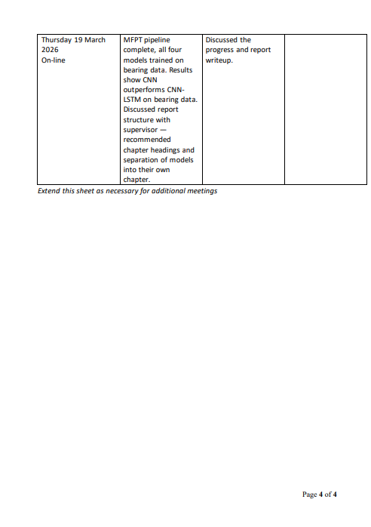

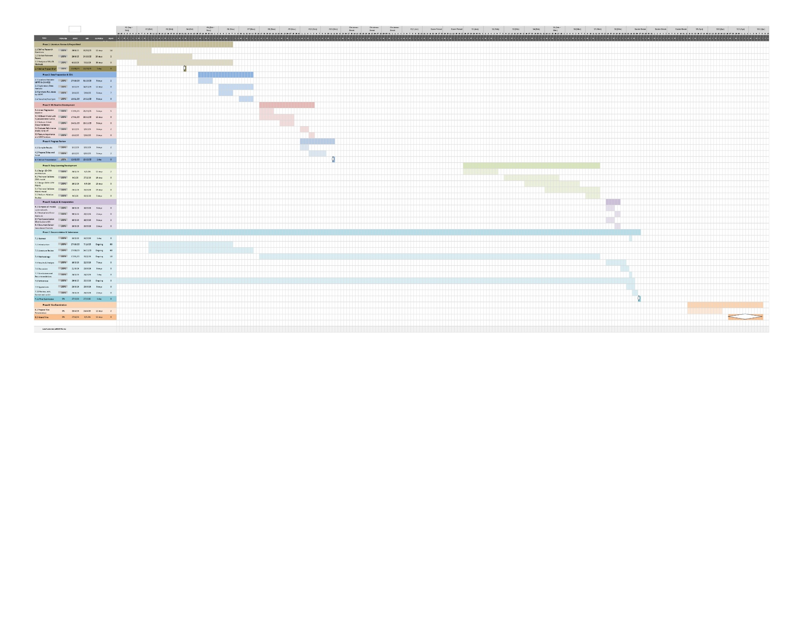
Appendix B: Gantt Chart



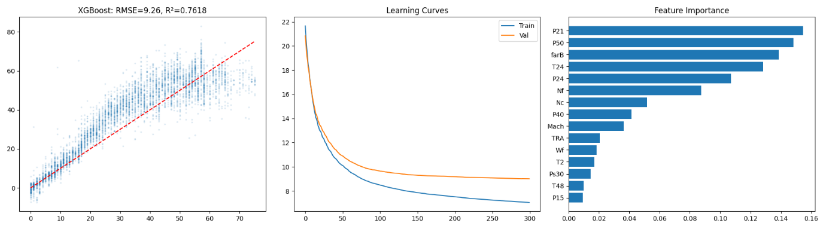
Appendix C: Additional Figures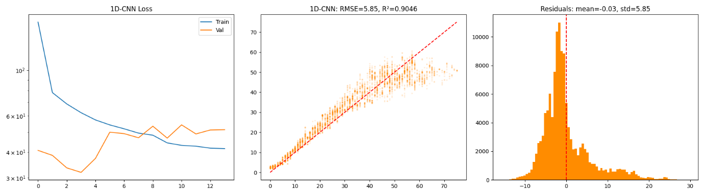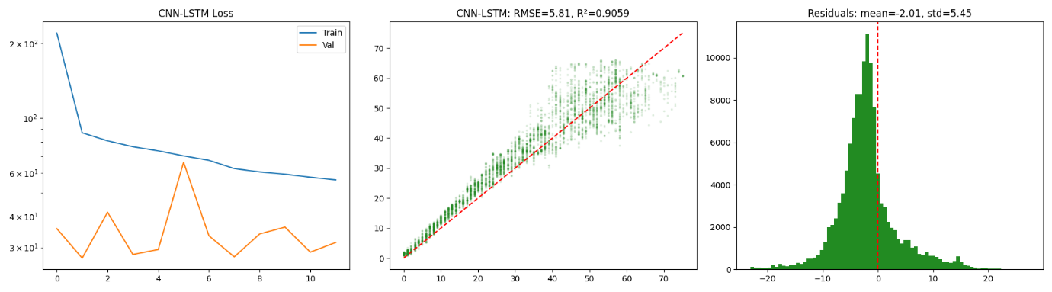

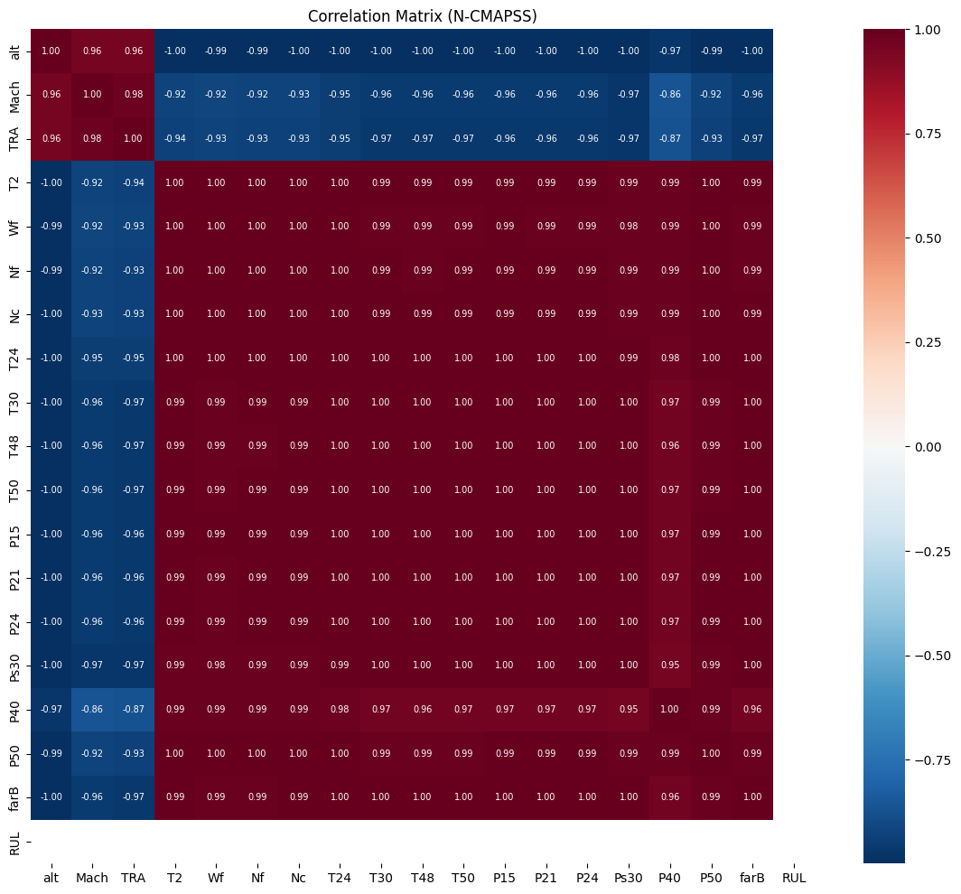

Appendix D: Code Samples + GitHub Repo Link
Full experiment code is available in GitHub
GitHub Repo:
Key code snapshots are provided below.
MFPT code in chronological order:
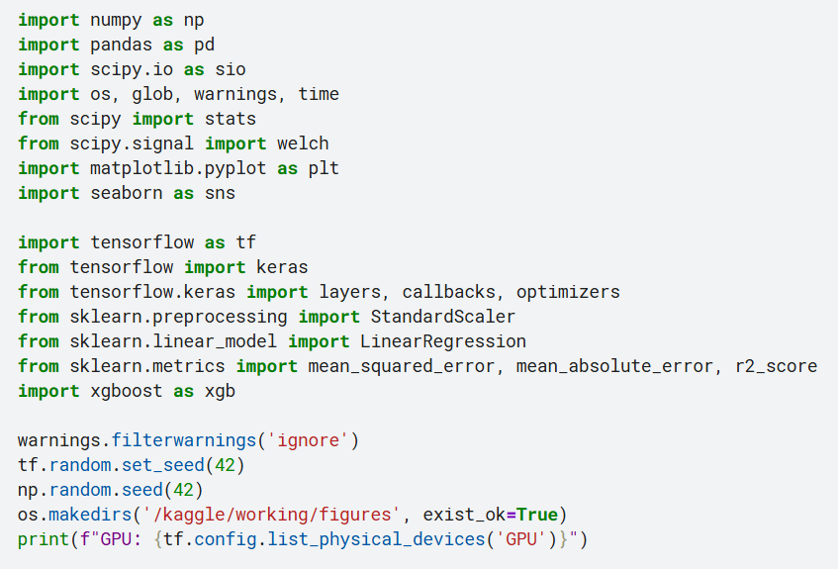
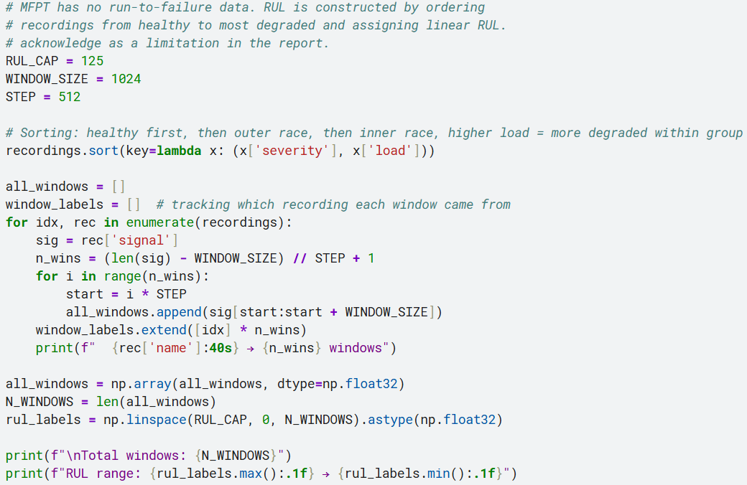
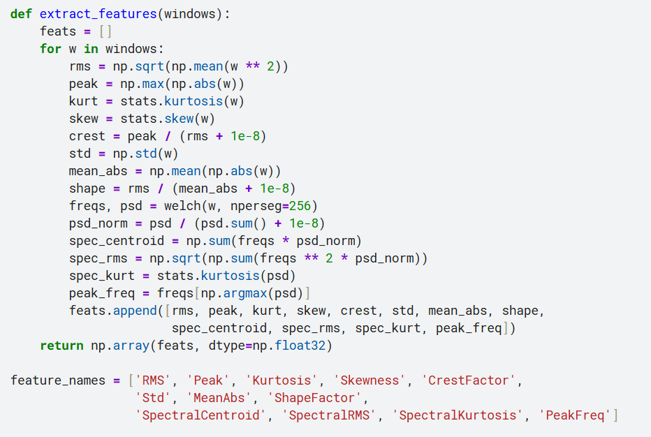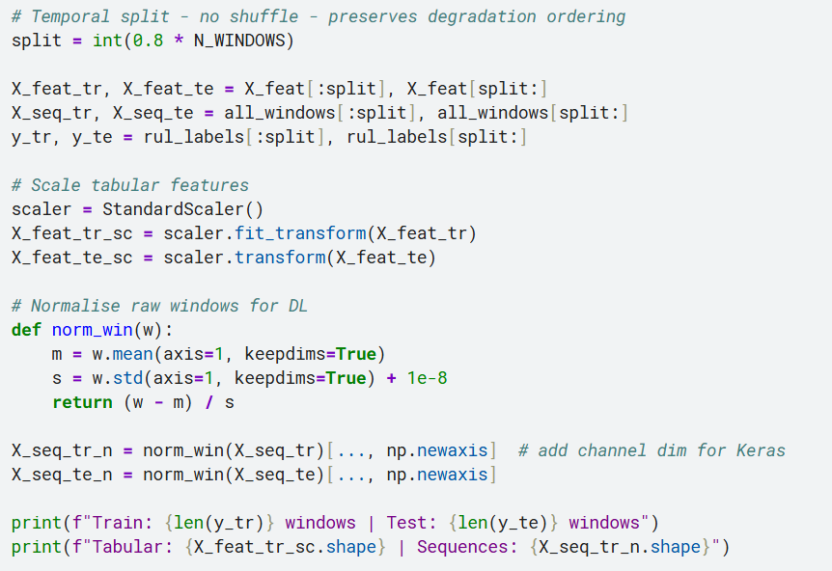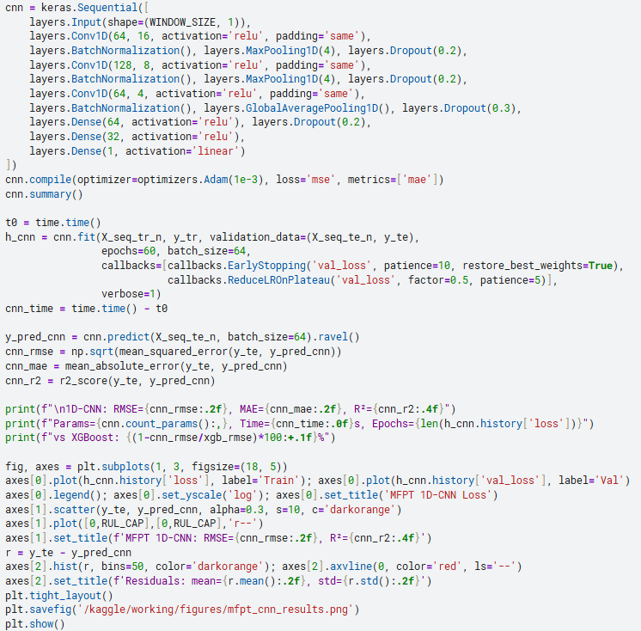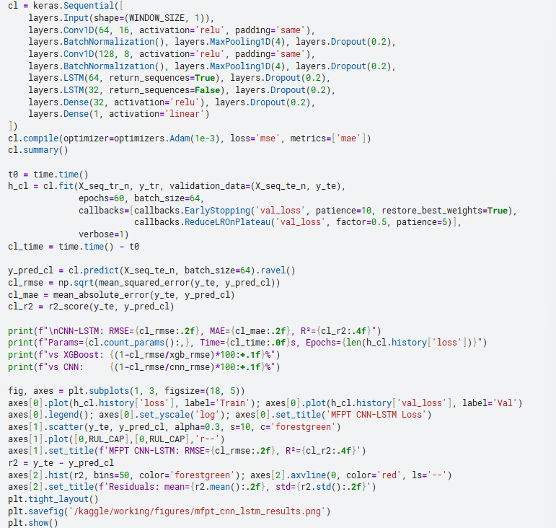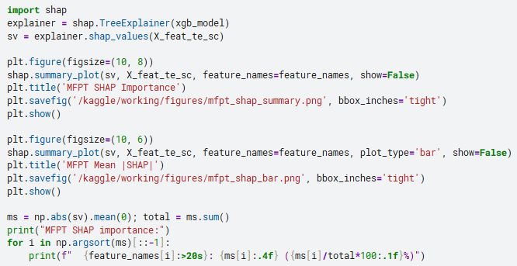
N-CMAPSS Turbofan in chronological order:
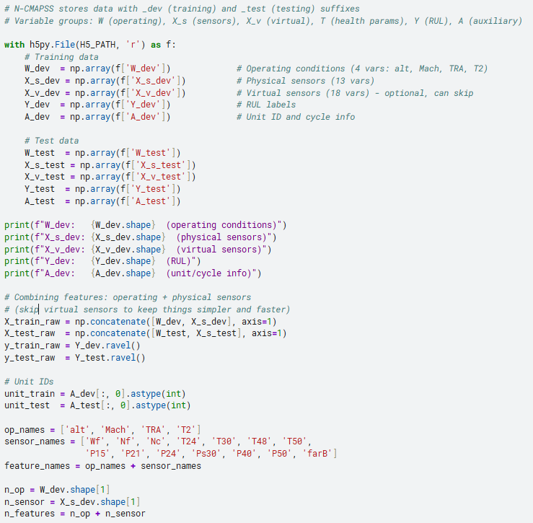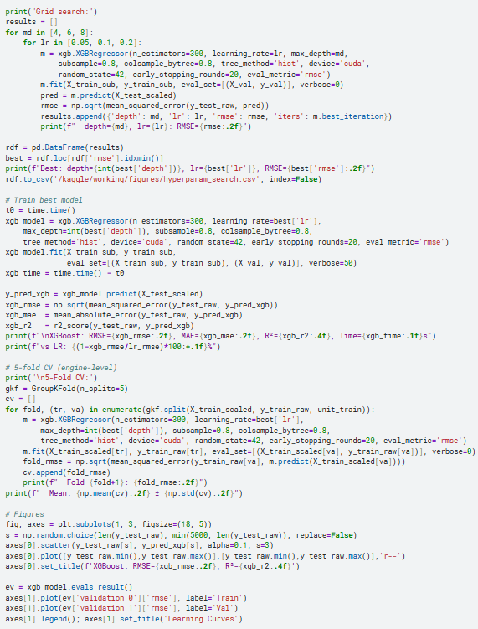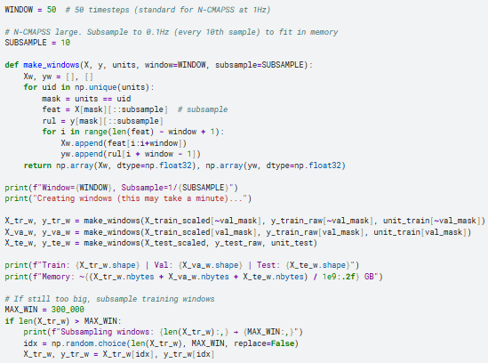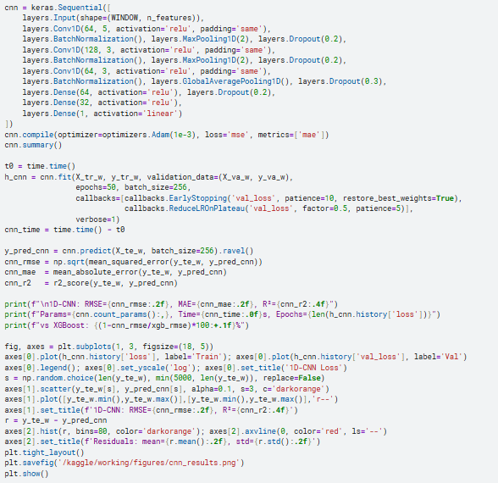
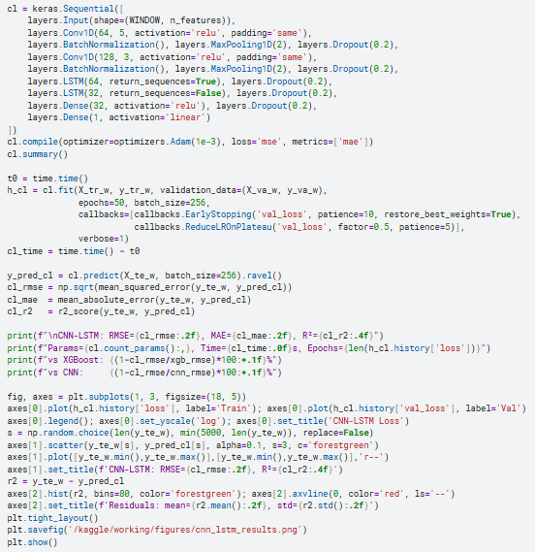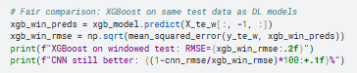

Appendix E: Risk Assessment
